**Assignment 2**

1. **Working with Java.lang.boolean**

b)Declare a method-local variable status of type boolean with the value true and convert it to a String using the toString method. (Hint: Use Boolean.toString(Boolean) )

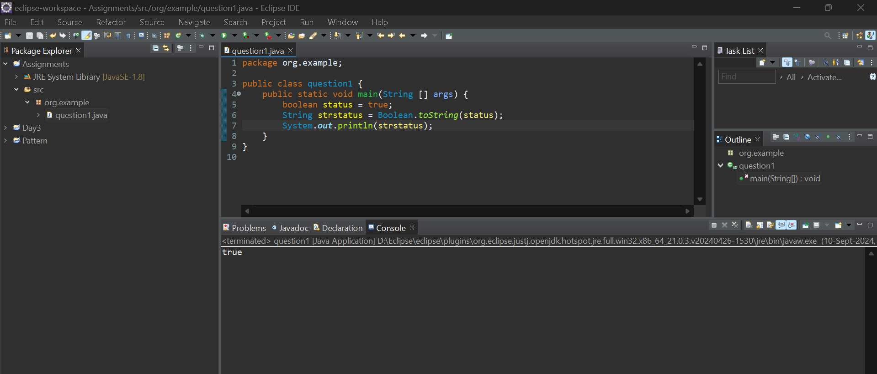

C) Declare a method-local variable strStatus of type String with the value "true" and convert it to a boolean using the parseBoolean method. (Hint: Use Boolean.parseBoolean(String)).

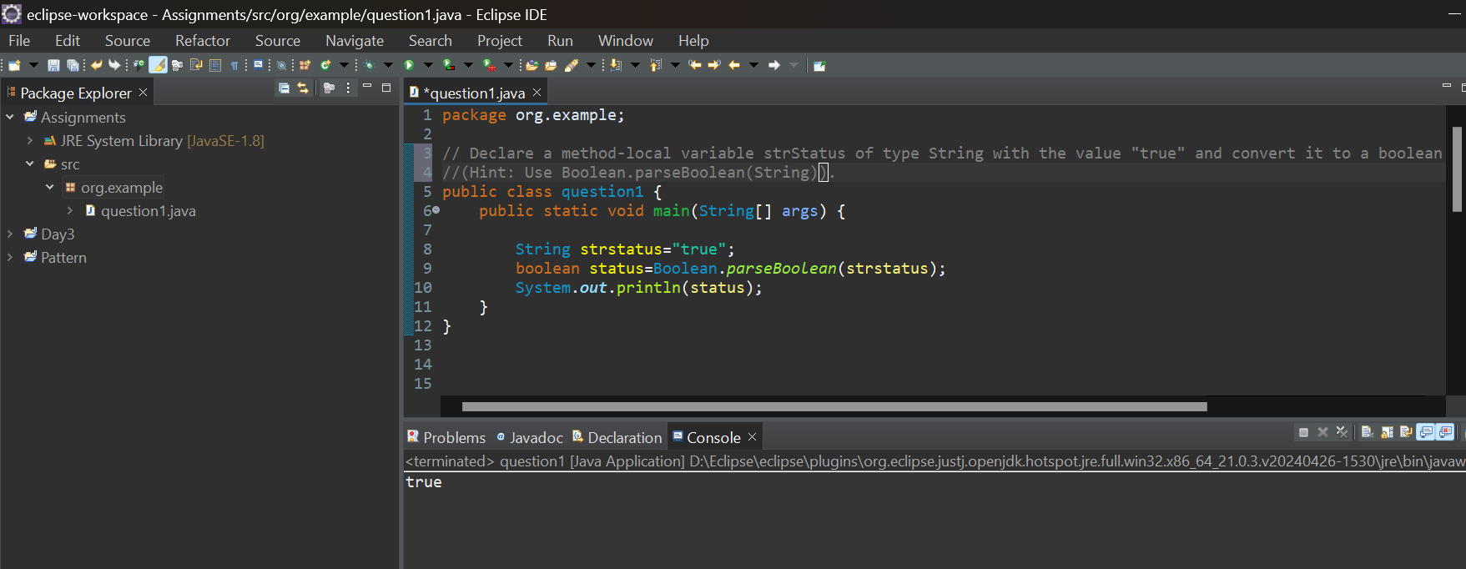

d) **.** Declare a method-local variable strStatus of type String with the value "1" or "0" and attempt to convert it to a boolean. (Hint: parseBoolean method will not work as expected with "1" or "0")

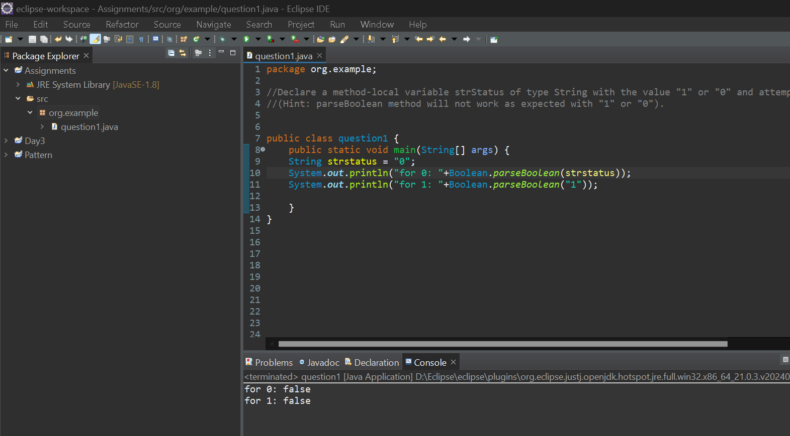

e) **.** Declare a method-local variable status of type boolean with the value true and convert it to the corresponding wrapper class using Boolean.valueOf(). (Hint: Use Boolean.valueOf(boolean)).

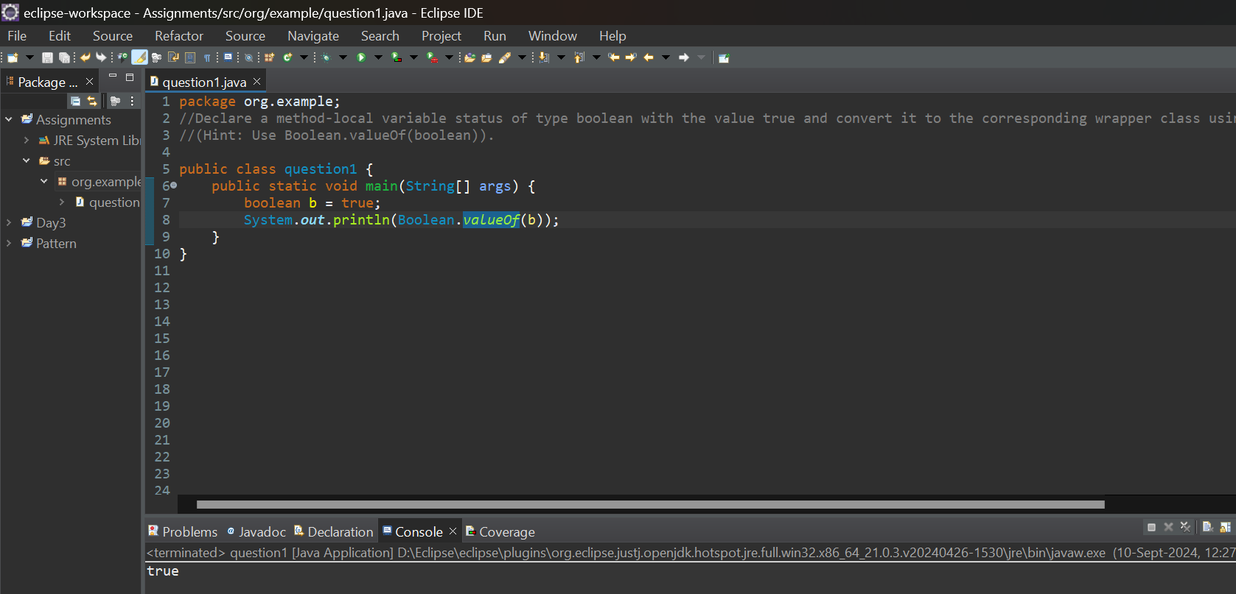

**f)**Declare a method-local variable strStatus of type String with the value "true" and convert it to the corresponding wrapper class using Boolean.valueOf(). (Hint: Use Boolean.valueOf(String))

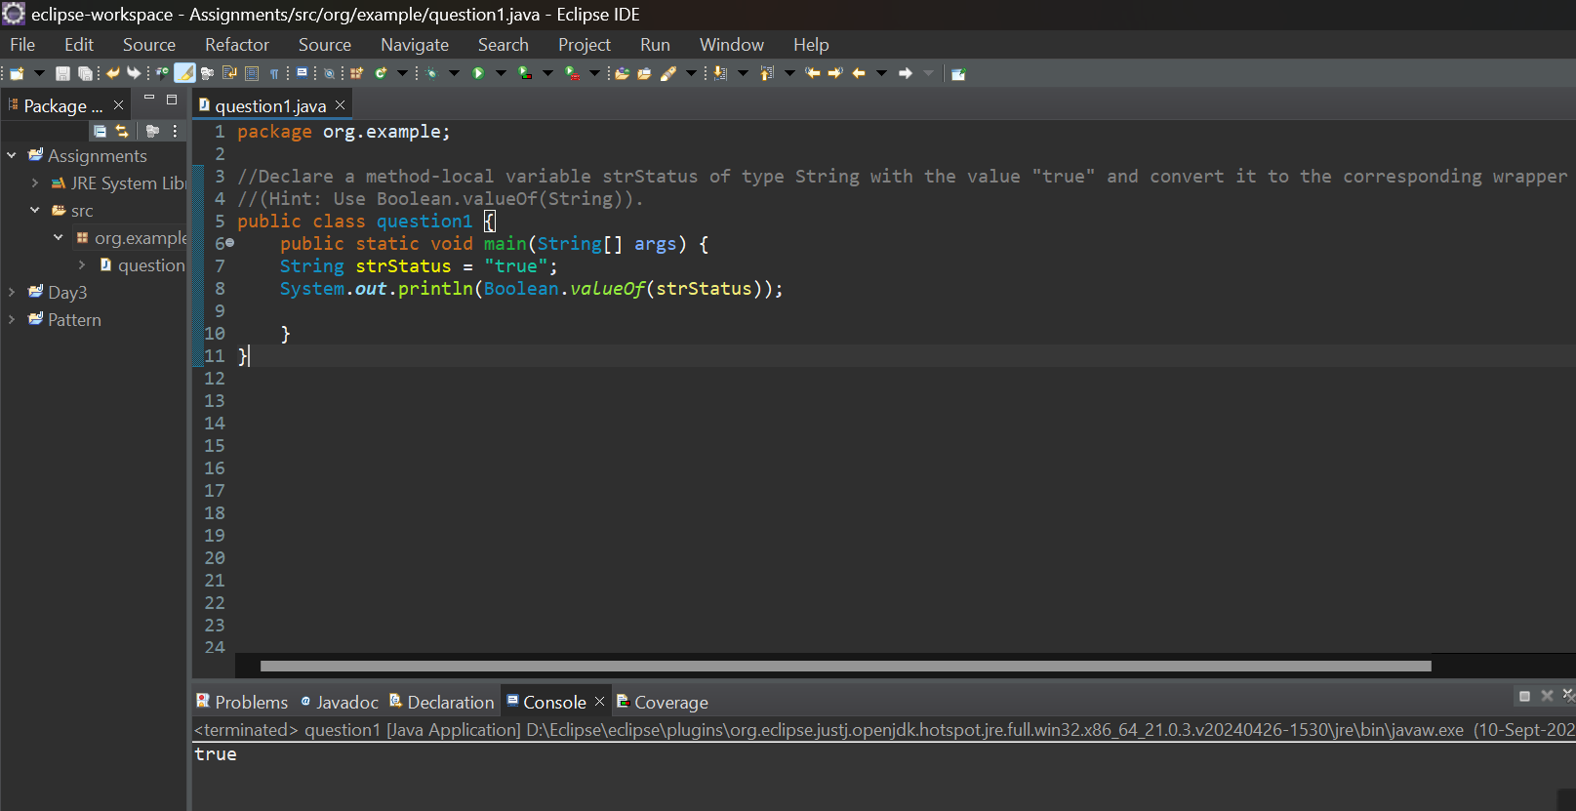

2.Working with java.lang.byte

a) Write a program to test how many bytes are used to represent a byte value using the BYTES field. (Hint: Use Byte.BYTES).

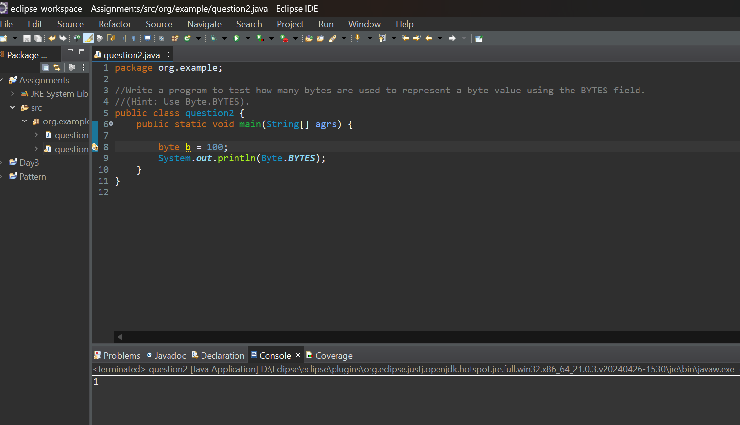

b) Write a program to find the minimum and maximum values of byte using the MIN_VALUE and MAX_VALUE fields. (Hint: Use Byte.MIN_VALUE and Byte.MAX_VALUE).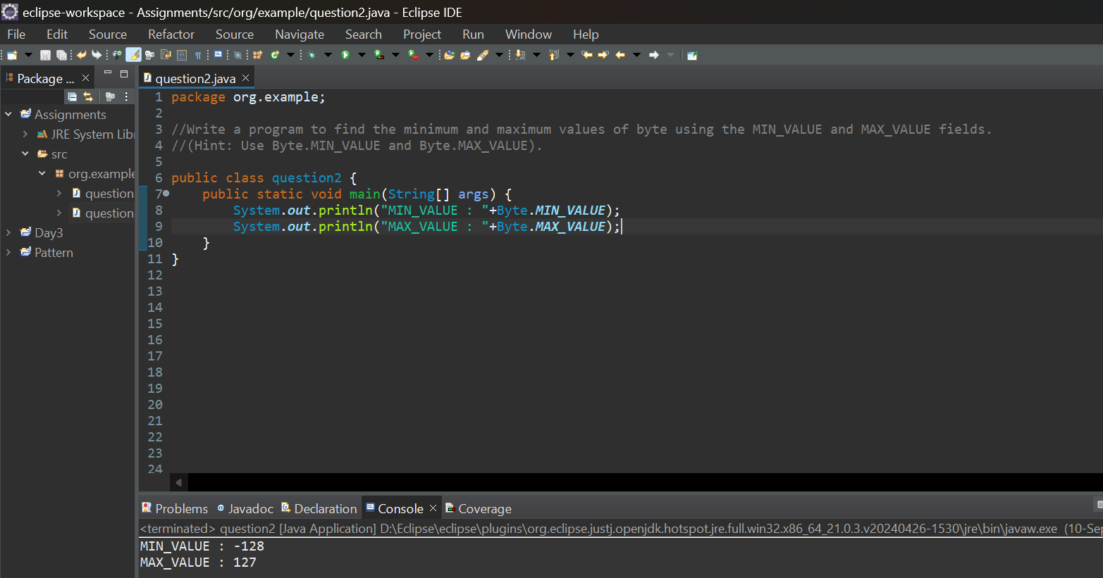

c) Declare a method-local variable number of type byte with some value and convert it toString using the toString method. (Hint: Use Byte.toString(byte)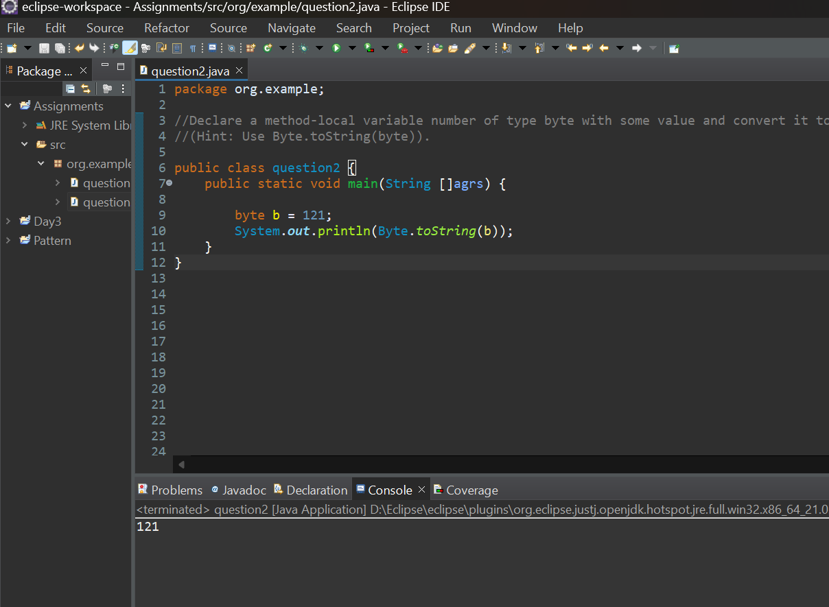

d) **.** Declare a method-local variable strNumber of type String with some value and convert it to a byte value using the parseByte method. (Hint: Use Byte.parseByte(String)).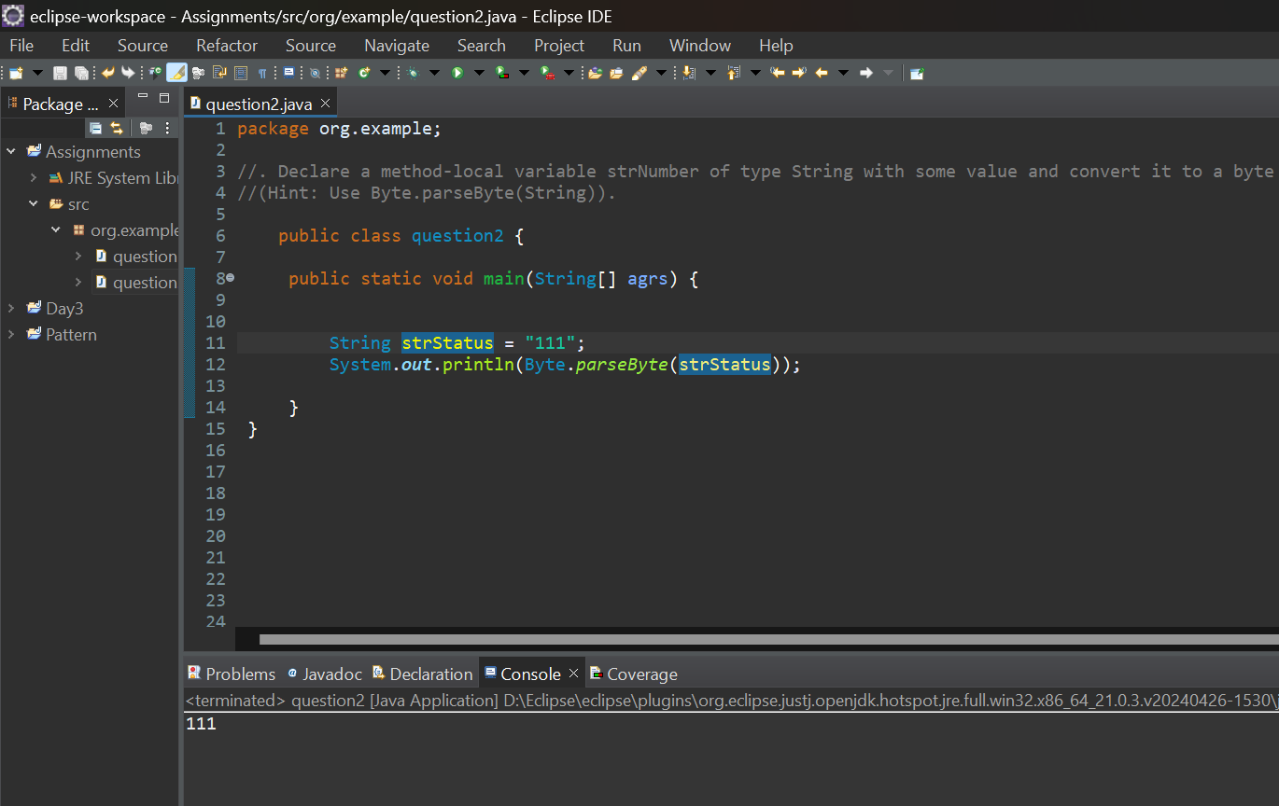

e) Declare a method-local variable strNumber of type String with the value "Ab12Cd3" and attempt to convert it to a byte value. (Hint: parseByte method will throw a NumberFormatException).

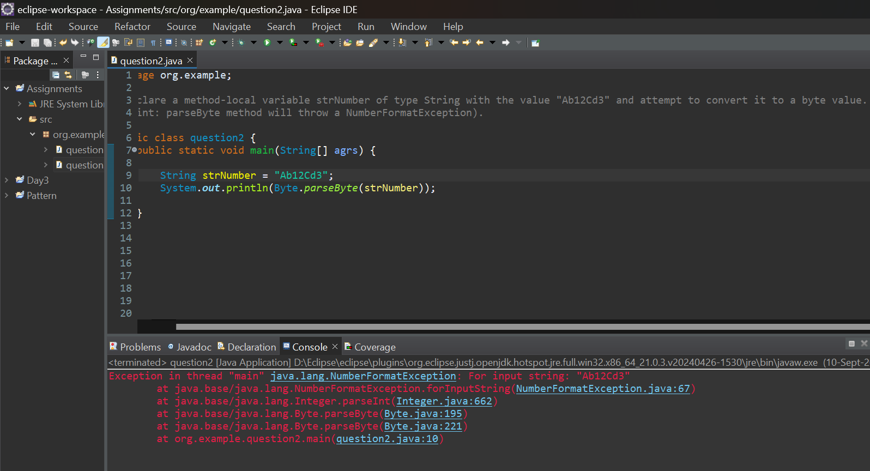

f) Declare a method-local variable number of type byte with some value and convert it to the corresponding wrapper class using Byte.valueOf(). (Hint: Use Byte.valueOf(byte)).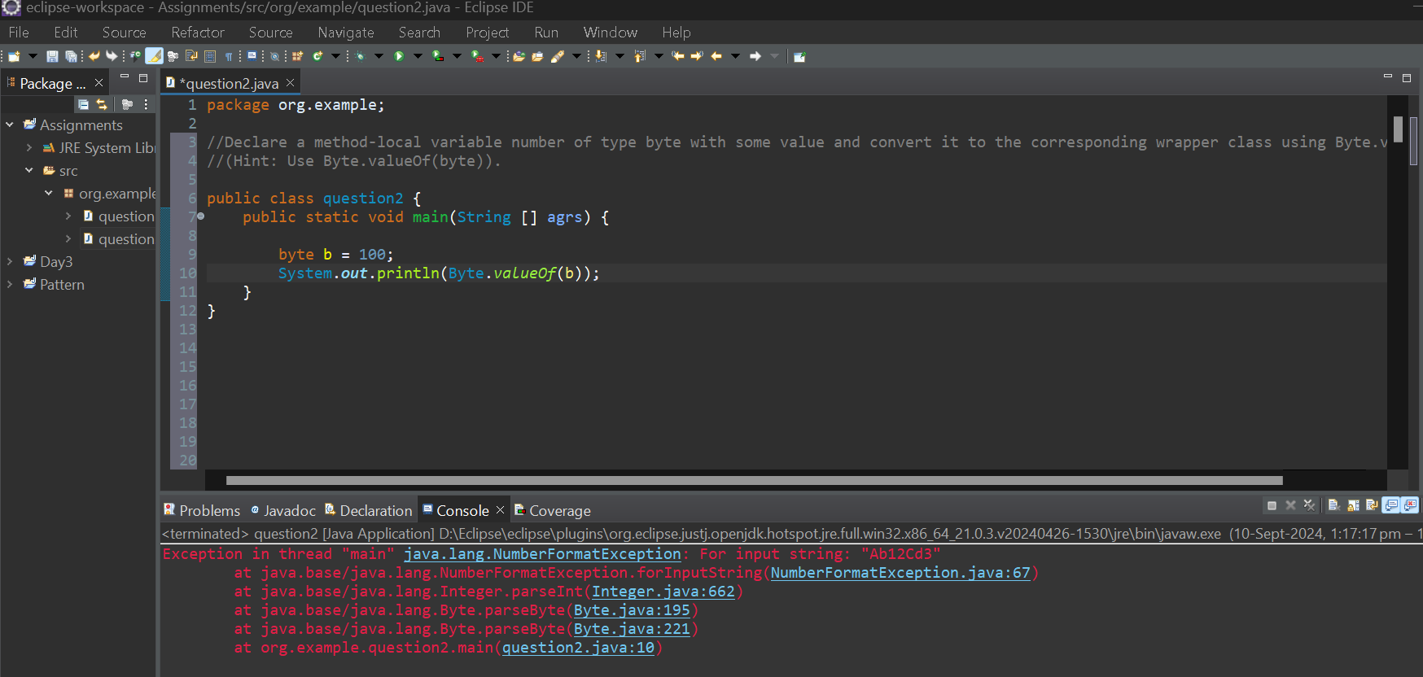

g) **.** Declare a method-local variable strNumber of type String with some byte value and convert it to the corresponding wrapper class using Byte.valueOf(). (Hint: Use Byte.valueOf(String)).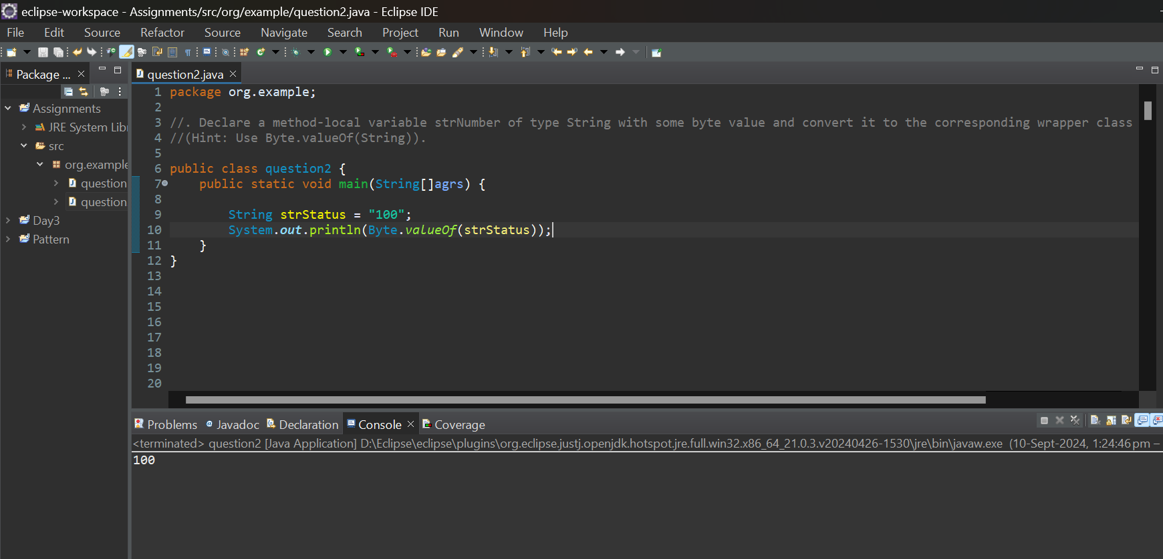

h) Experiment with converting a byte value into other primitive types or vice versa and observe the results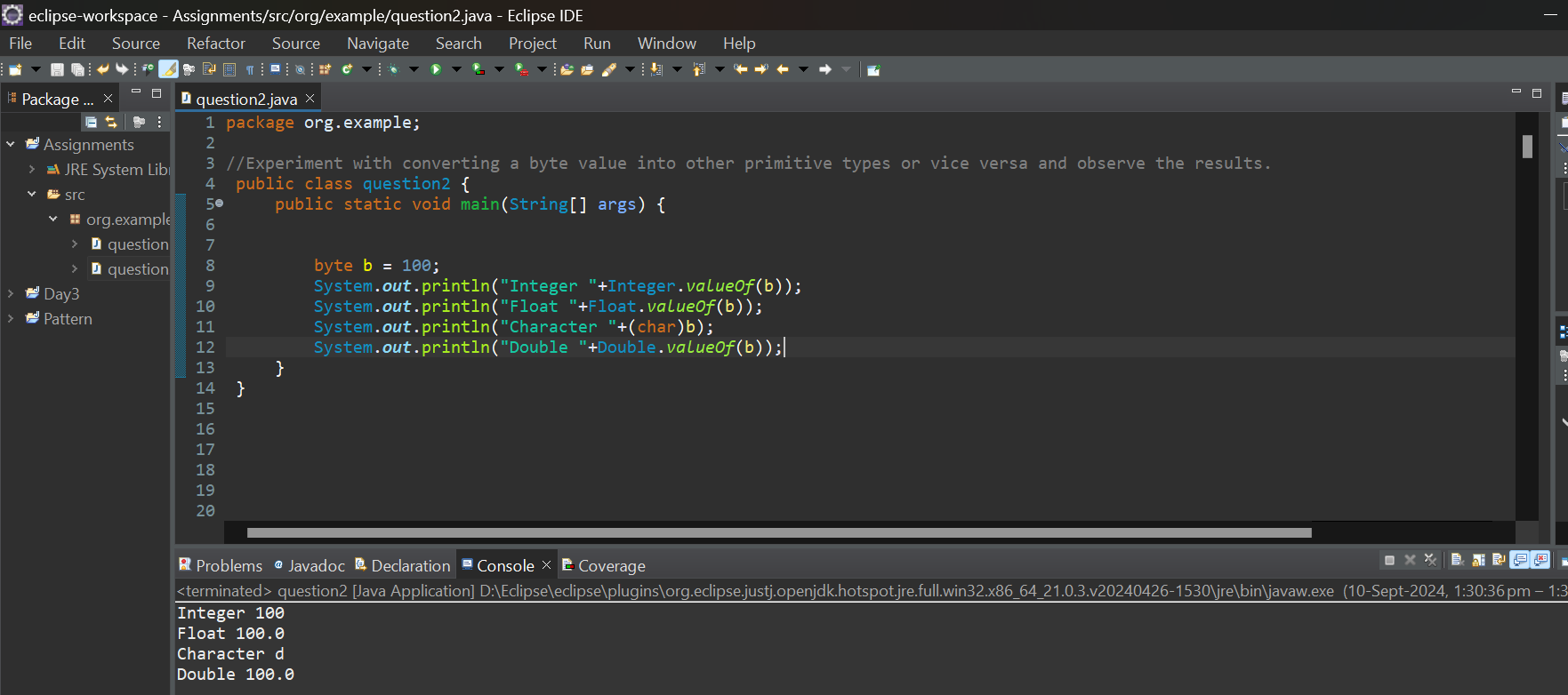

3.Working with java.lang.short

1. Write a program to test how many bytes are used to represent a short value using the BYTES field.(Hint: Use Short.BYTES).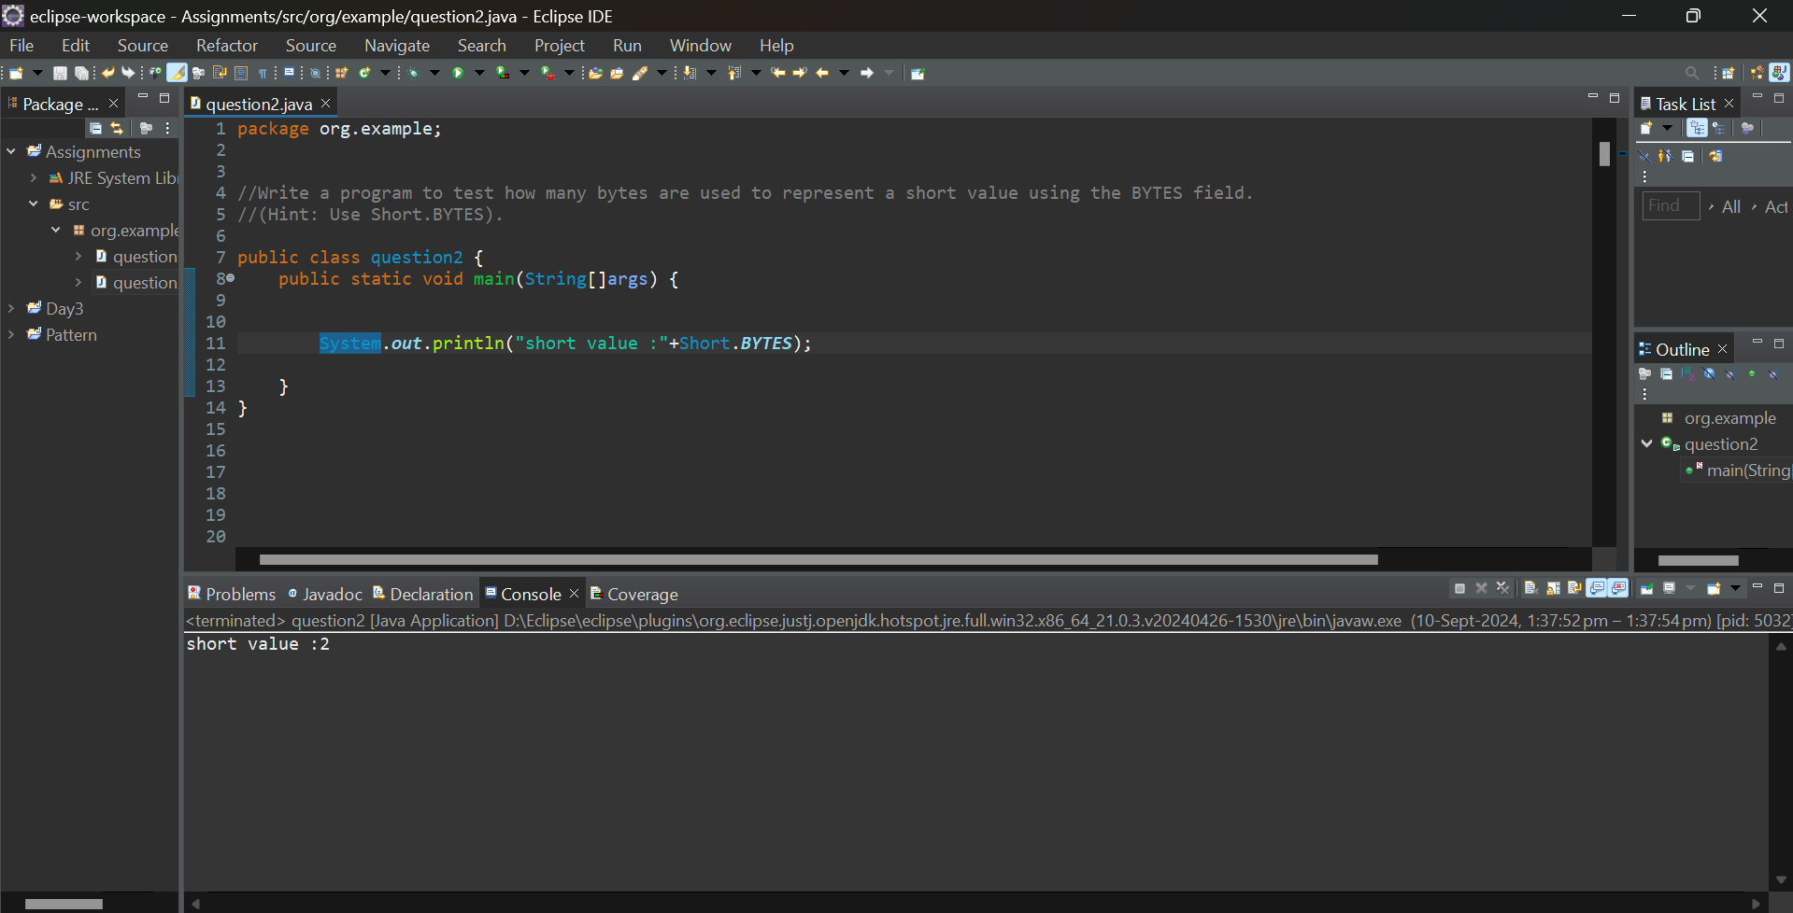
2. Write a program to find the minimum and maximum values of short using the MIN_VALUE and MAX_VALUE fields. (Hint: Use Short.MIN_VALUE and Short.MAX_VALUE).

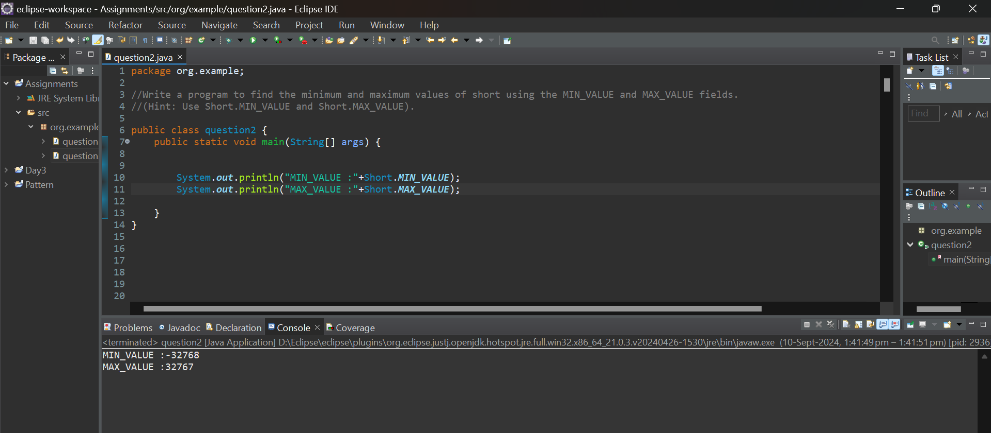

c) **.** Declare a method-local variable number of type short with some value and convert it to a String using the toString method. (Hint: Use Short.toString(short)).

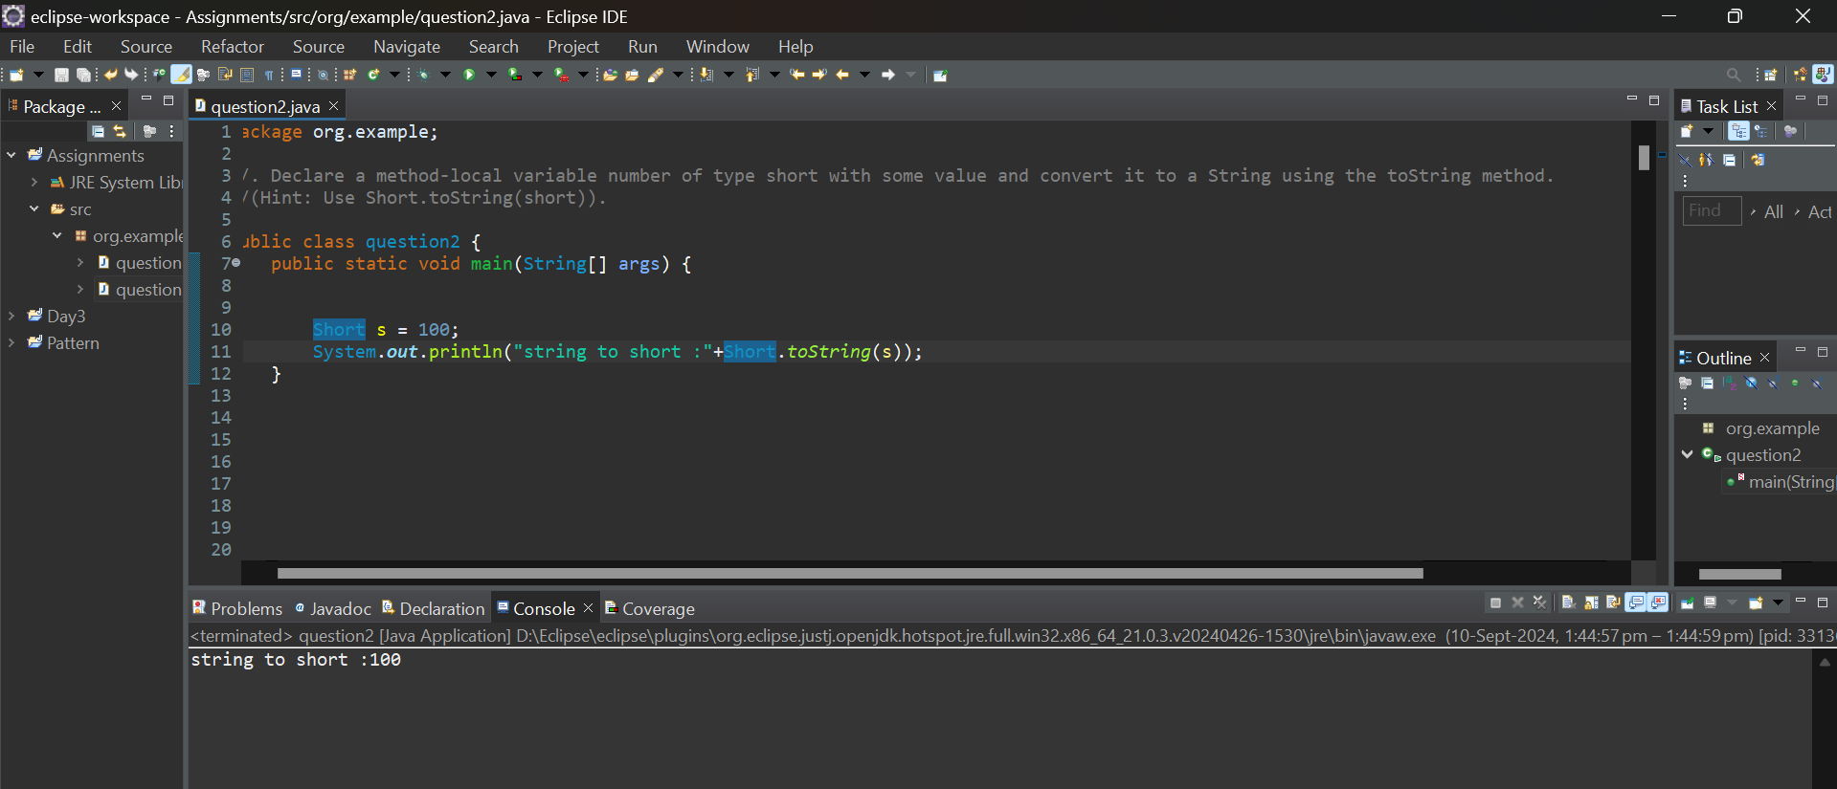

1. **.** Declare a method-local variable strNumber of type String with some value and convert it to a short value using the parseShort method. (Hint: Use Short.parseShort(String)).

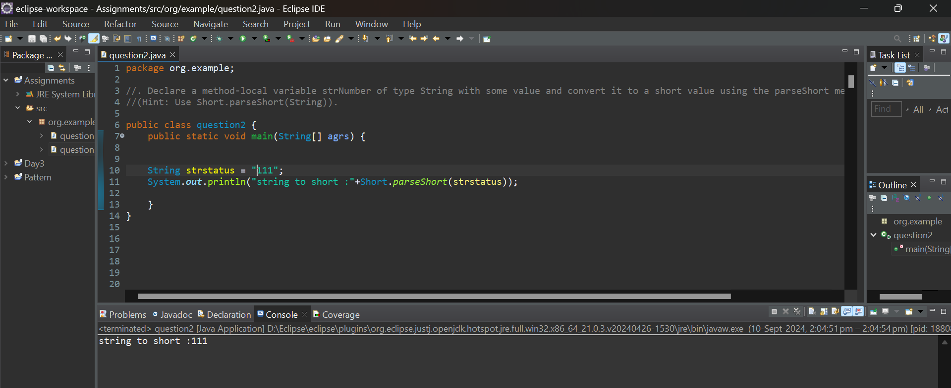

d)Declare a method-local variable strNumber of type String with the value "Ab12Cd3" and attempt to convert it to a short value. (Hint: parseShort method will throw a NumberFormatException).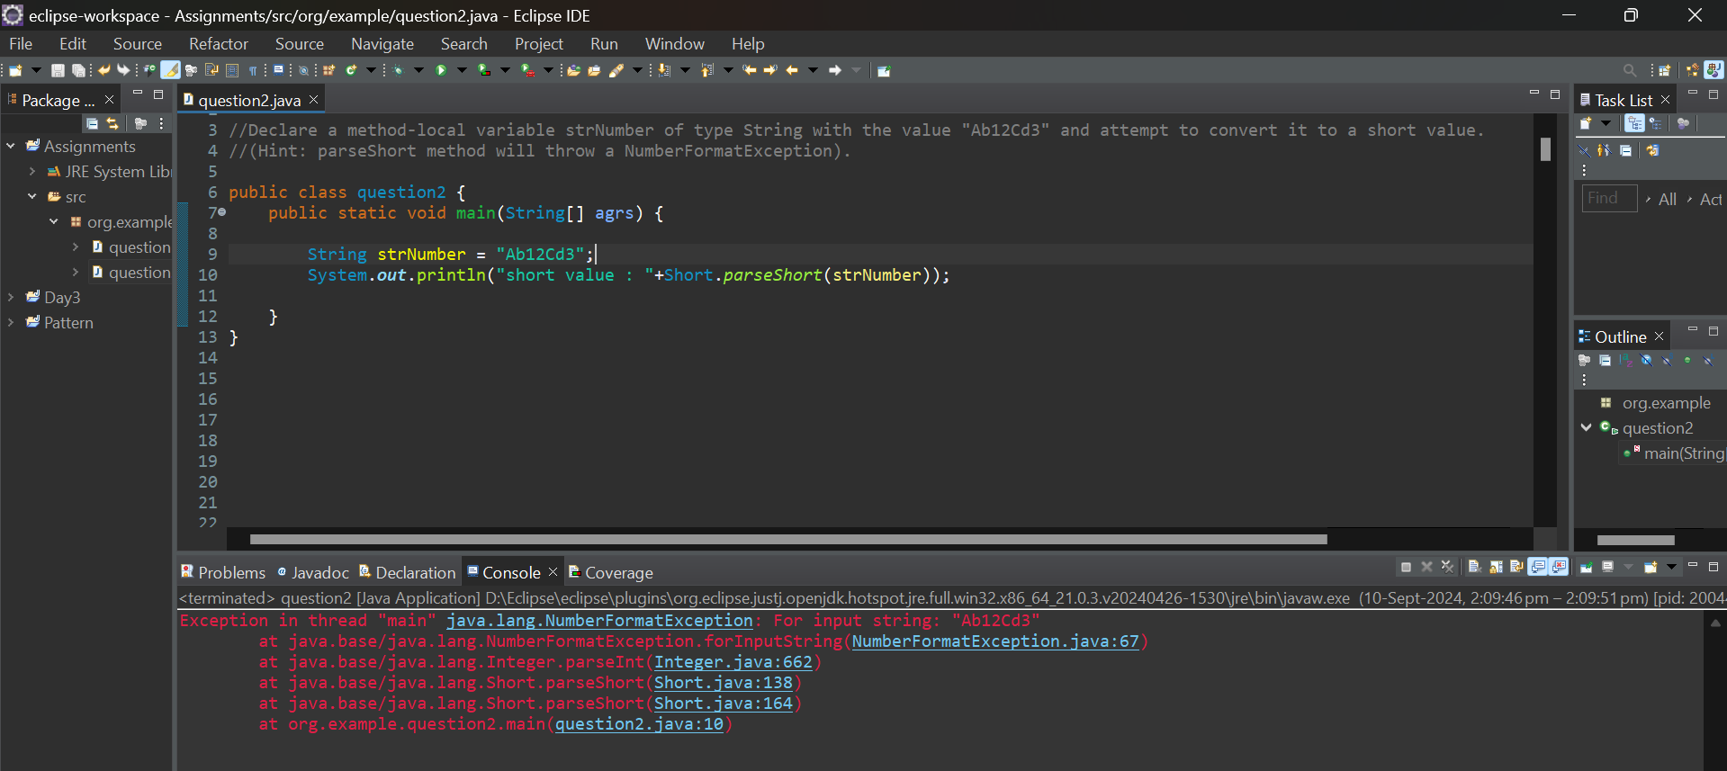

e) Declare a method-local variable number of type short with some value and convert it to the corresponding wrapper class using Short.valueOf(). (Hint: Use Short.valueOf(short))

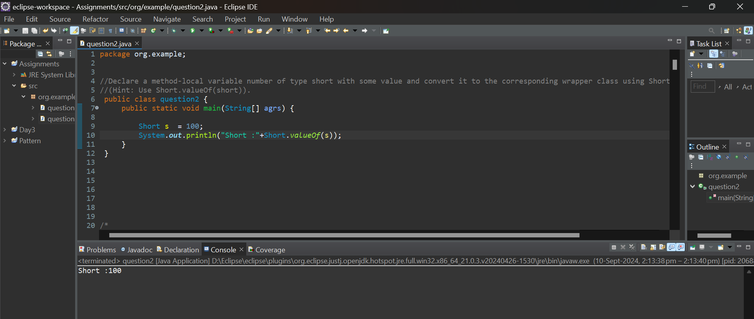

f) Declare a method-local variable strNumber of type String with some short value and convert it to the corresponding wrapper class using Short.valueOf(). (Hint: Use Short.valueOf(String)).

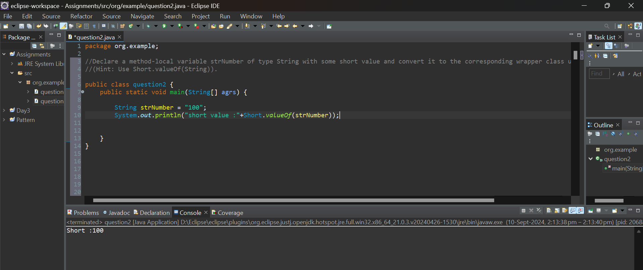

g) Experiment with converting a short value into other primitive types or vice versa and observe the results.

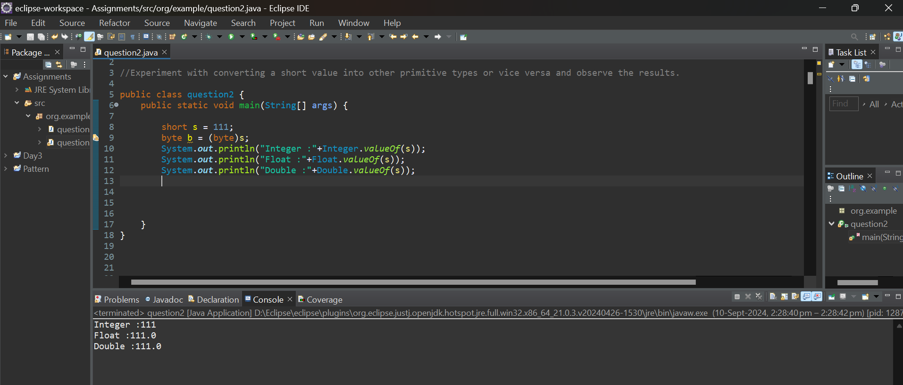

4.Working with java.lang.integer

a)Write a program to test how many bytes are used to represent an int value using the BYTES field. (Hint: Use Integer.BYTES).

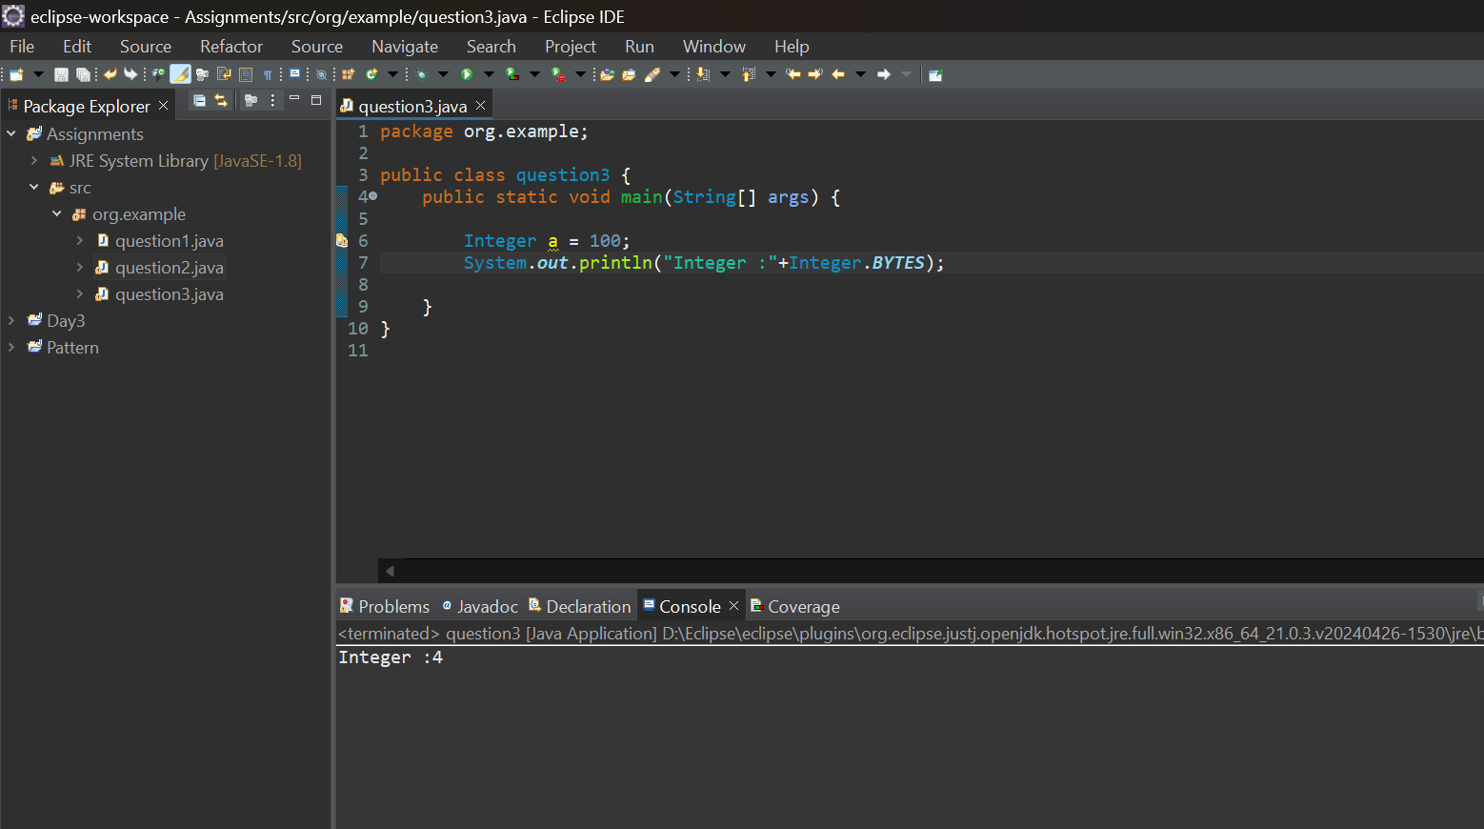

b) Write a program to find the minimum and maximum values of int using the MIN_VALUE and MAX_VALUE fields. (Hint: Use Integer.MIN_VALUE and Integer.MAX_VALUE).

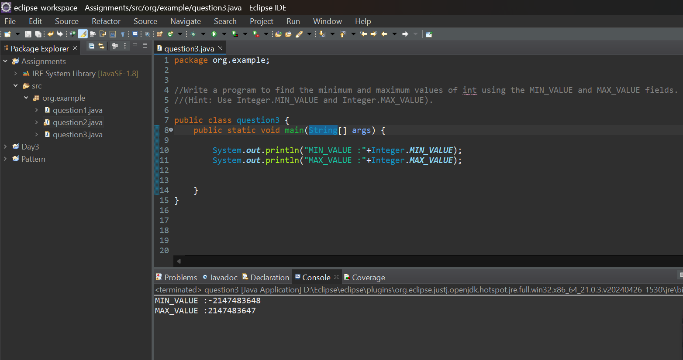

C) Declare a method-local variable number of type int with some value and convert it to a String using the toString method. (Hint: Use Integer.toString(int)).

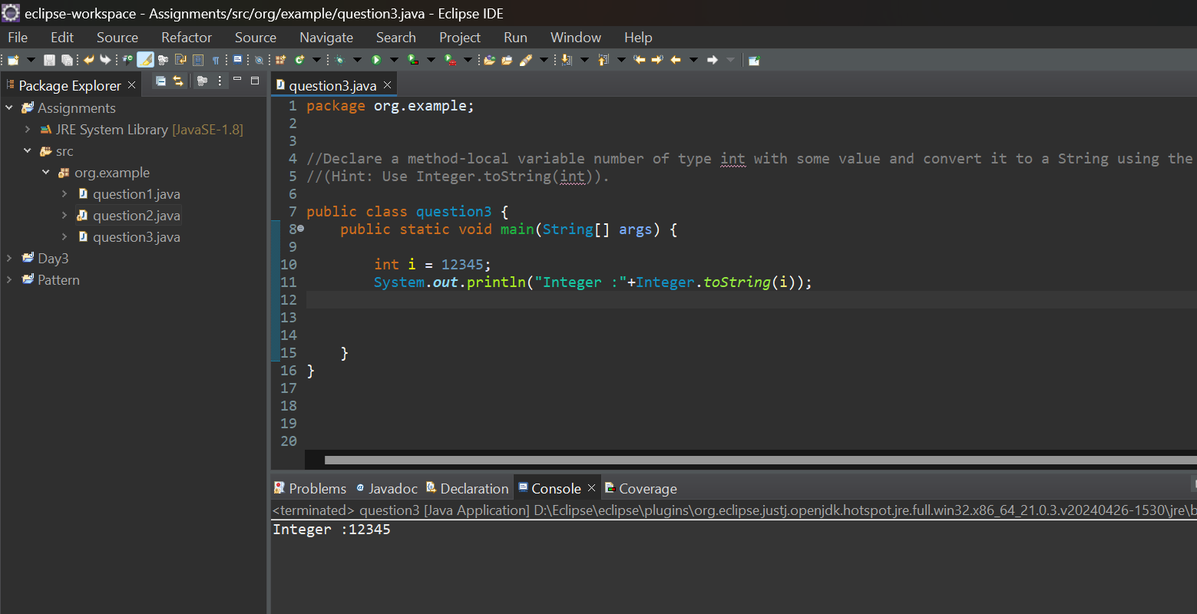

1. Declare a method-local variable strNumber of type String with some value and convert it to an int value using the parseInt method. (Hint: Use Integer.parseInt(String)).

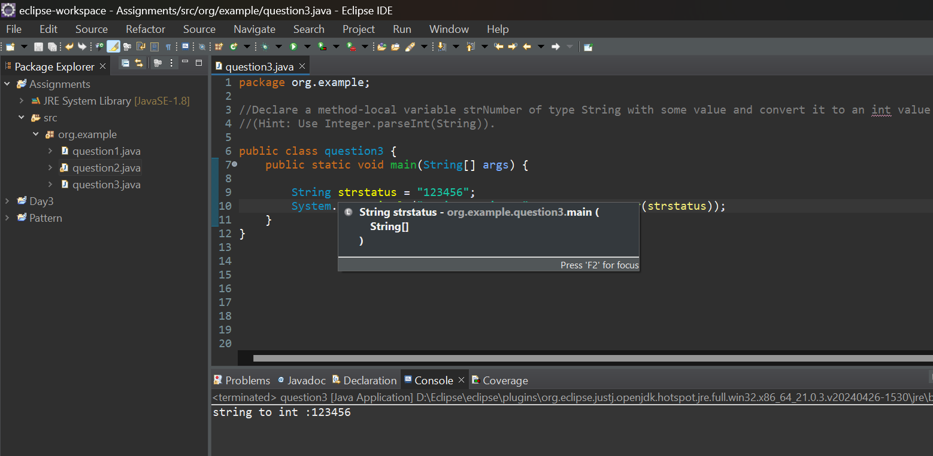

1. Declare a method-local variable strNumber of type String with the value "Ab12Cd3" and attempt to convert it to an int value. (Hint: parseInt method will throw a NumberFormatException).

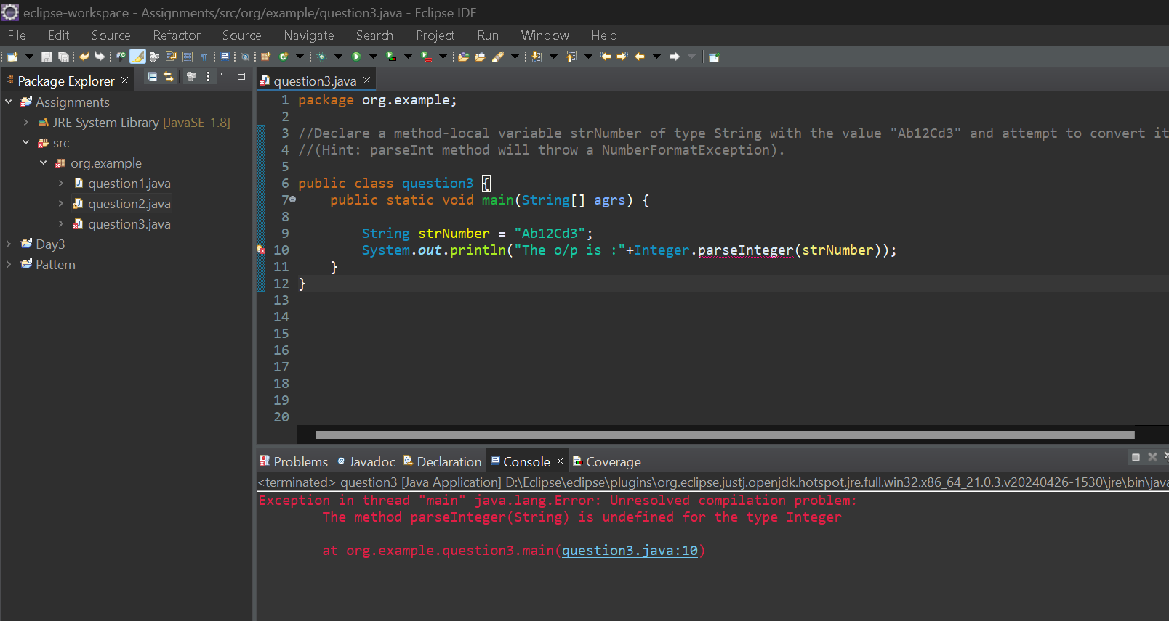

1. Declare a method-local variable number of type int with some value and convert it to the corresponding wrapper class using Integer.valueOf(). (Hint: Use Integer.valueOf(int)).

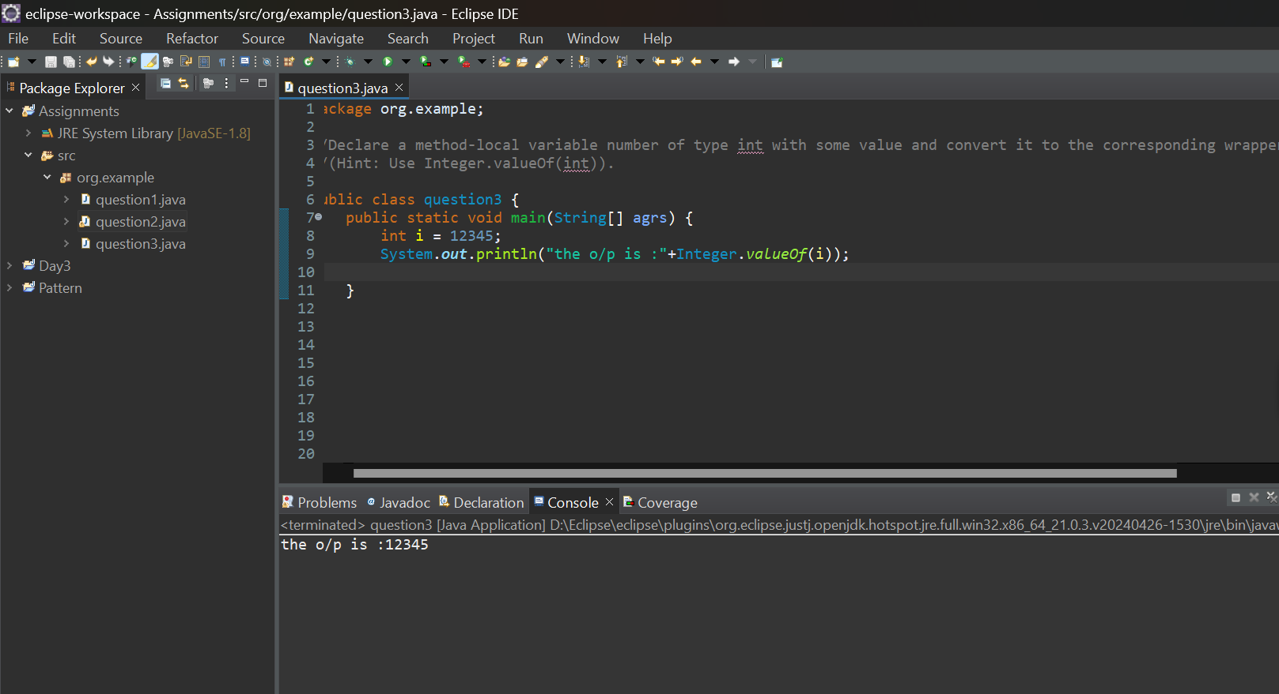

1. Declare a method-local variable strNumber of type String with some integer value and convert it to the corresponding wrapper class using Integer.valueOf(). (Hint: Use Integer.valueOf(String)).

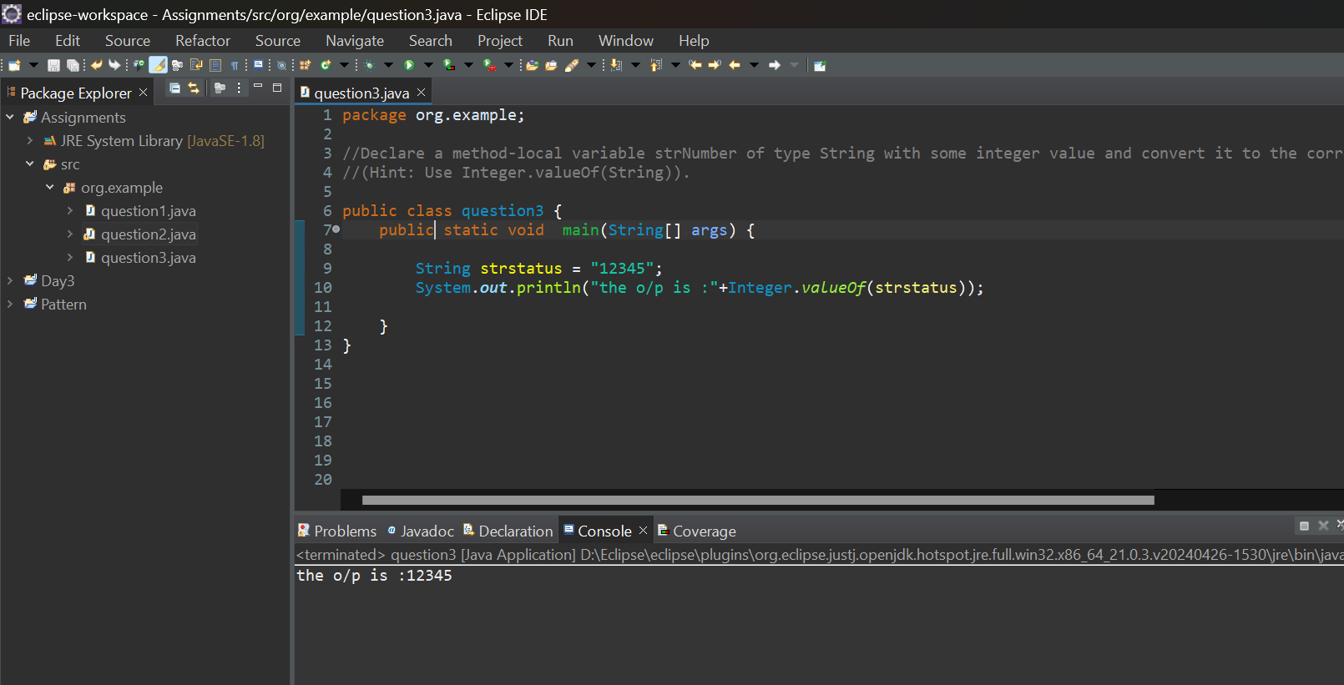

1. Declare two integer variables with values 10 and 20, and add them using a method from the Integer class. (Hint: Use Integer.sum(int, int)).

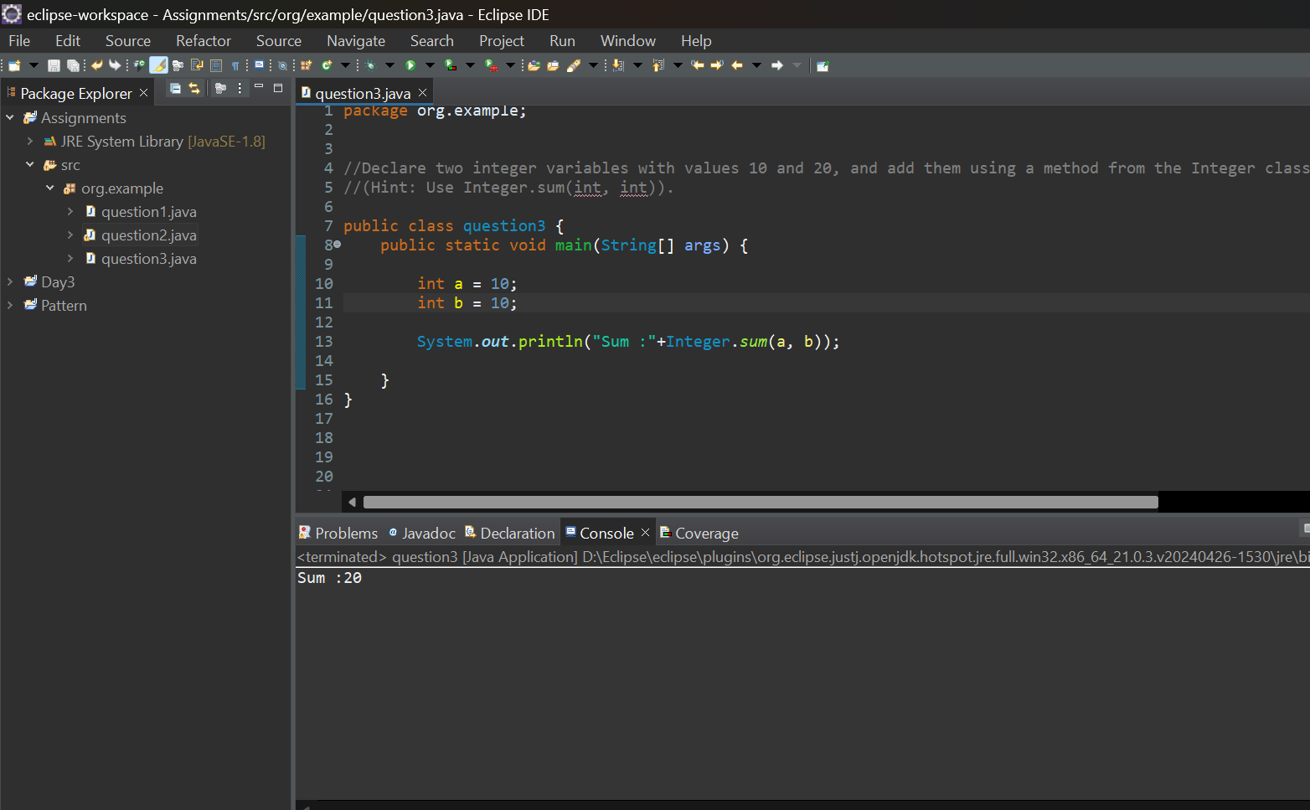

1. Declare two integer variables with values 10 and 20, and find the minimum and maximum values using the Integer class. (Hint: Use Integer.min(int, int) and Integer.max(int, int)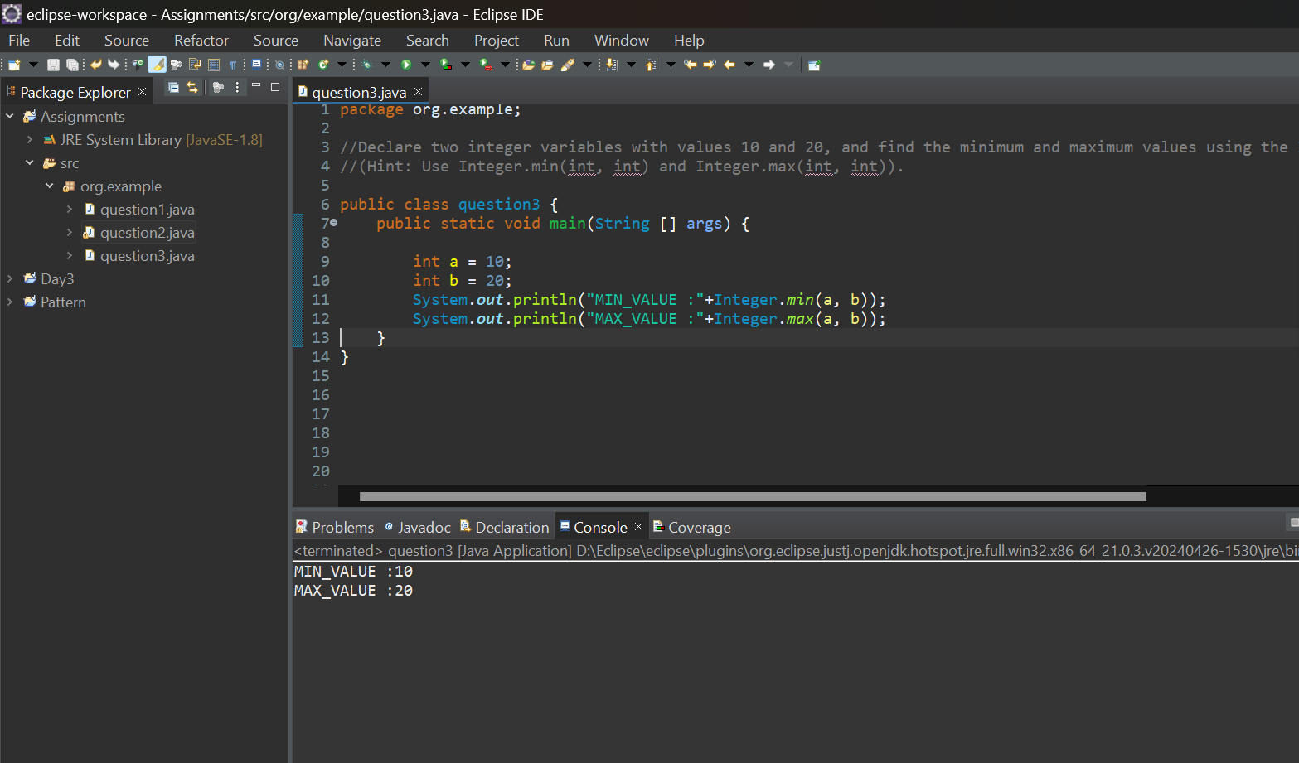

j)Declare an integer variable with the value 7. Convert it to binary, octal, and hexadecimal strings using methods from the Integer class. (Hint: Use Integer.toBinaryString(int), Integer.toOctalString(int), and Integer.toHexString(int)).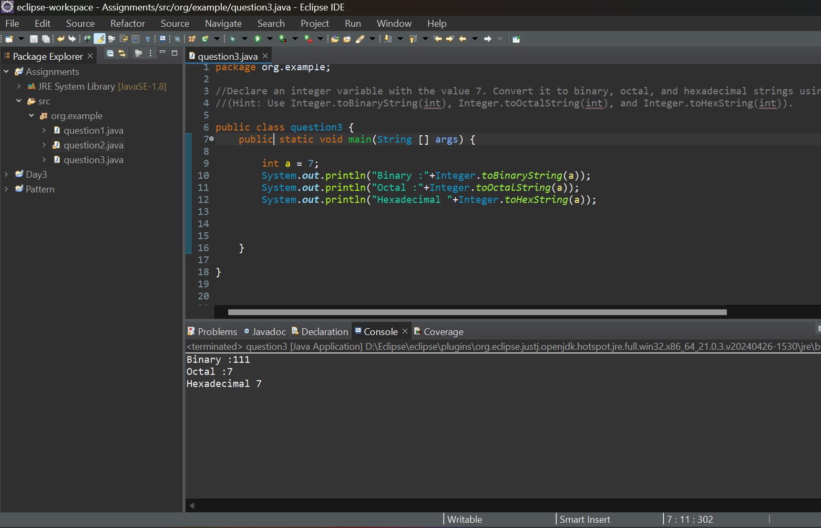

5.Working with java.lang.long

a)Write a program to test how many bytes are used to represent a long value using the BYTES field. (Hint: Use Long.BYTES).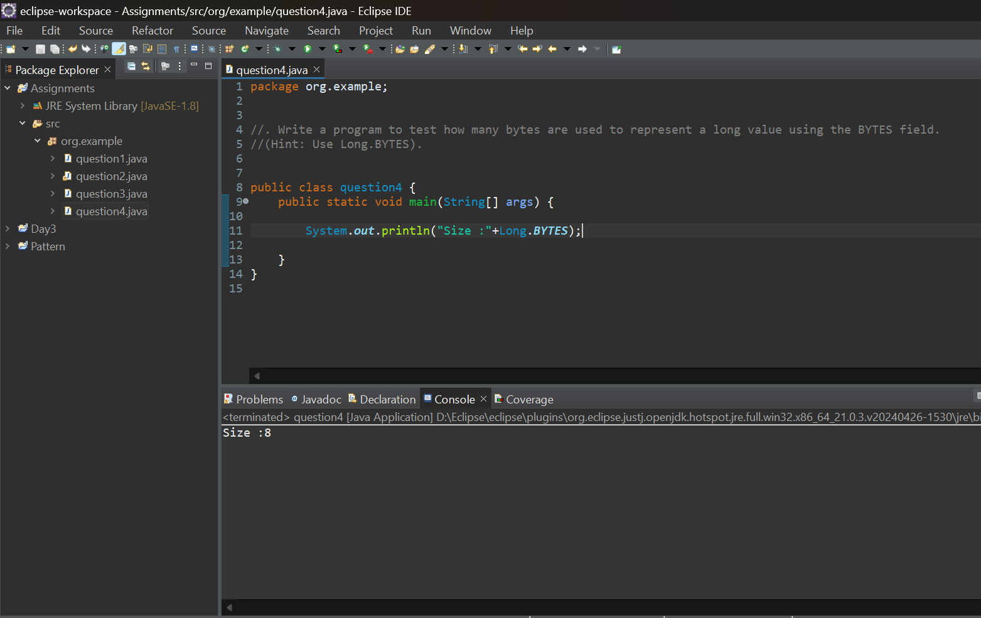

b) Write a program to find the minimum and maximum values of long using the MIN_VALUE and MAX_VALUE fields. (Hint: Use Long.MIN_VALUE and Long.MAX_VALUE).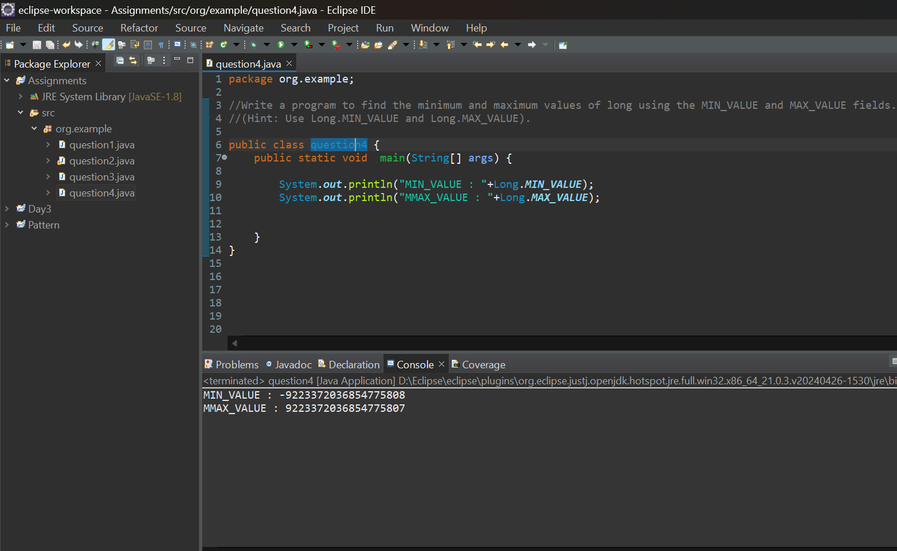

c) **.** Declare a method-local variable number of type long with some value and convert it to a String using the toString method. (Hint: Use Long.toString(long)).

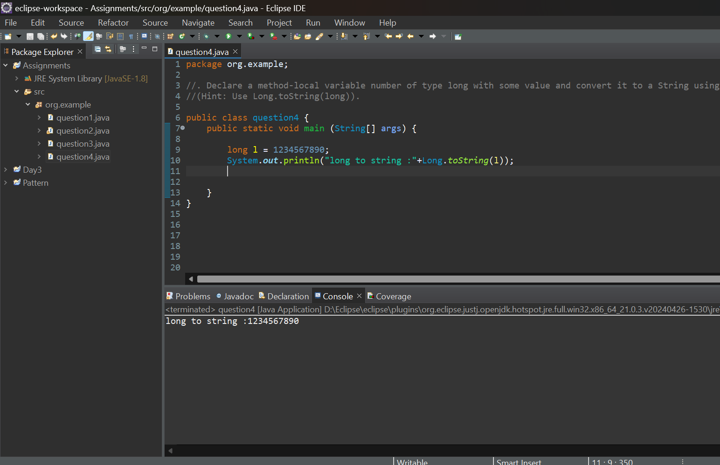

d) Declare a method-local variable strNumber of type String with some value and convert it to a long value using the parseLong method. (Hint: Use Long.parseLong(String)).

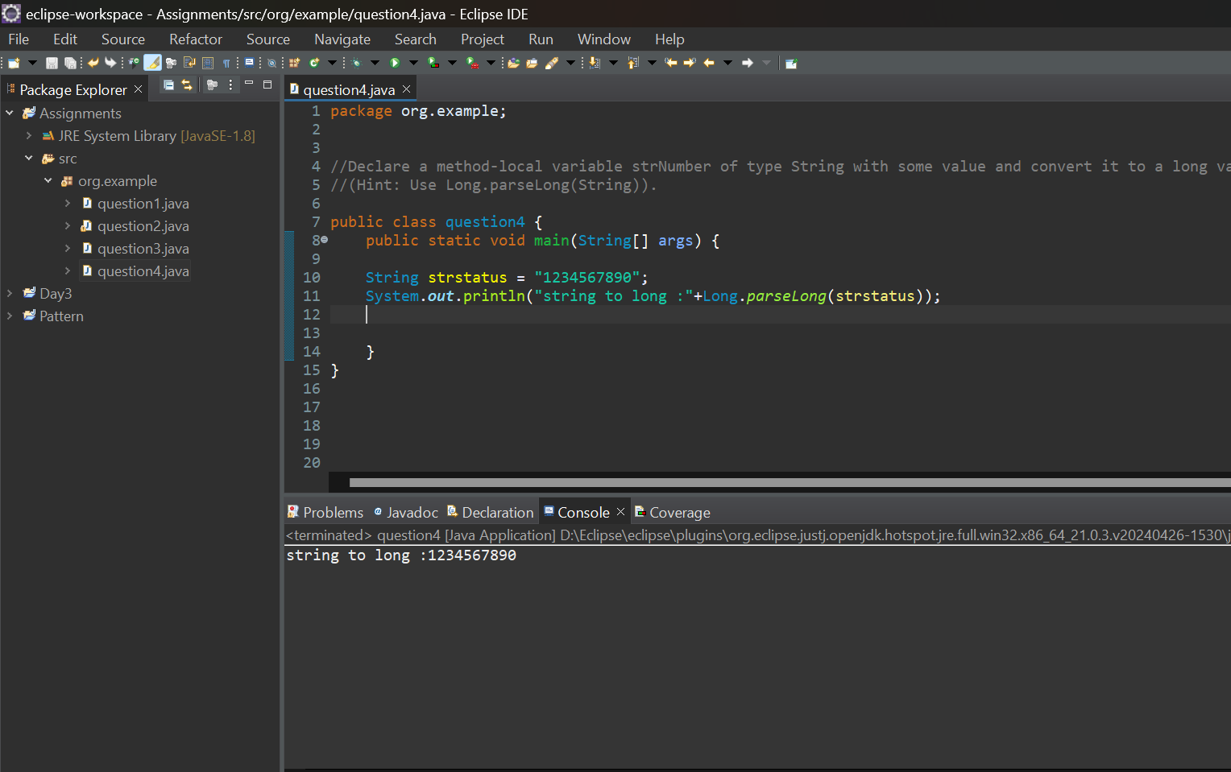

e) Declare a method-local variable strNumber of type String with the value "Ab12Cd3" and attempt to convert it to a long value. (Hint: parseLong method will throw a NumberFormatException)

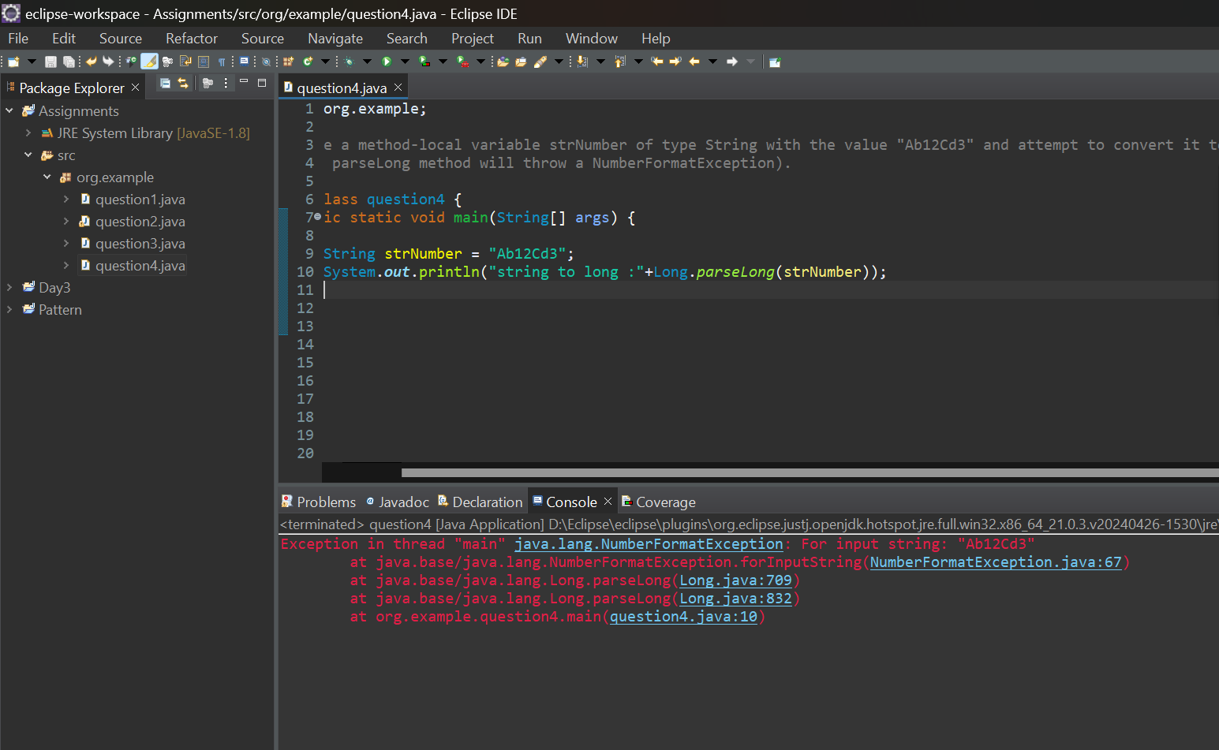

f) Declare a method-local variable number of type long with some value and convert it to the corresponding wrapper class using Long.valueOf(). (Hint: Use Long.valueOf(long)).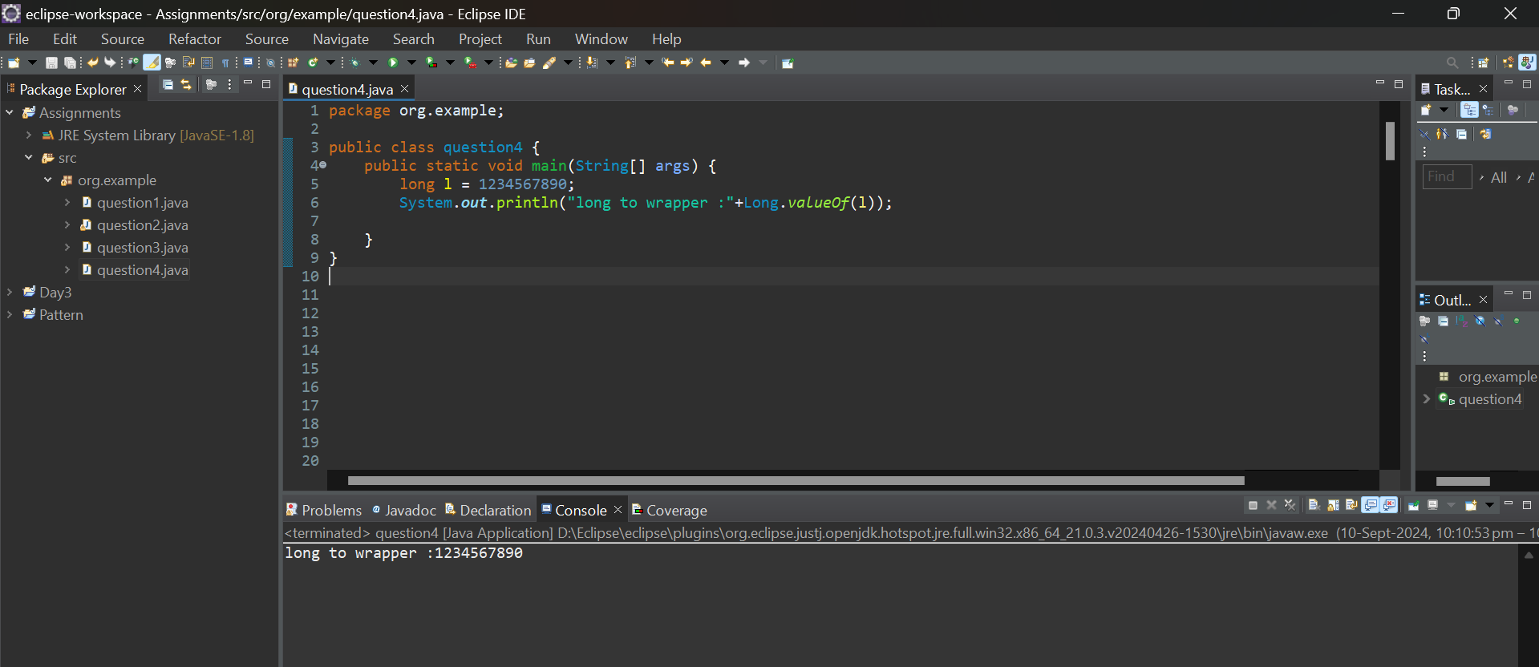

**h.** Declare a method-local variable strNumber of type String with some long value and convert it to the corresponding wrapper class using Long.valueOf(). (Hint: Use Long.valueOf(String)).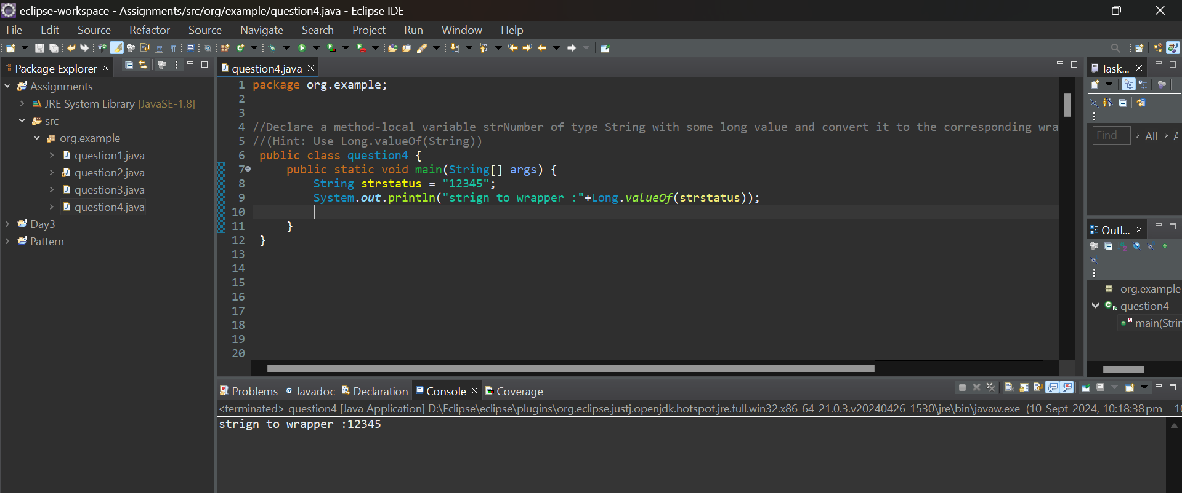

**i.** Declare two long variables with values 1123 and 9845, and add them using a method from the Long class. (Hint: Use Long.sum(long, long)).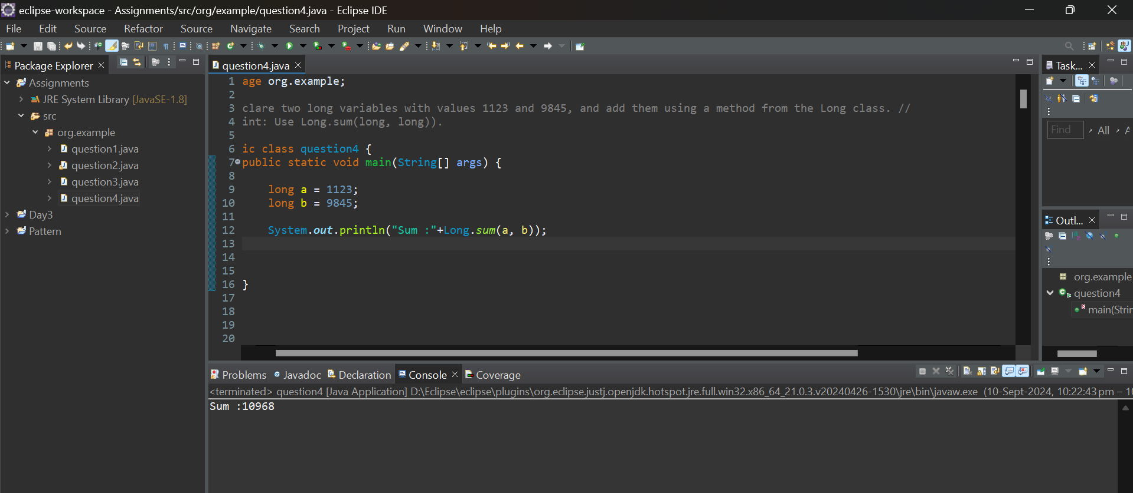

j)Declare two long variables with values 1122 and 5566, and find the minimum and maximum values using the Long class. (Hint: Use Long.min(long, long) and Long.max(long, long)).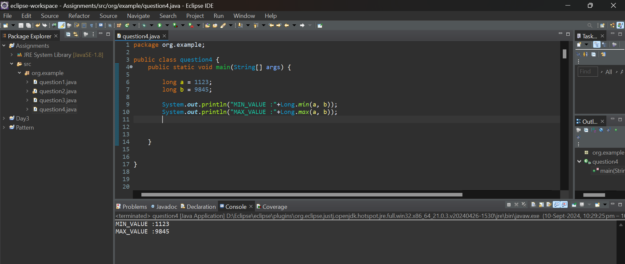

**k.** Declare a long variable with the value 7. Convert it to binary, octal, and hexadecimal strings using methods from the Long class. (Hint: Use Long.toBinaryString(long), Long.toOctalString(long), and Long.toHexString(long)).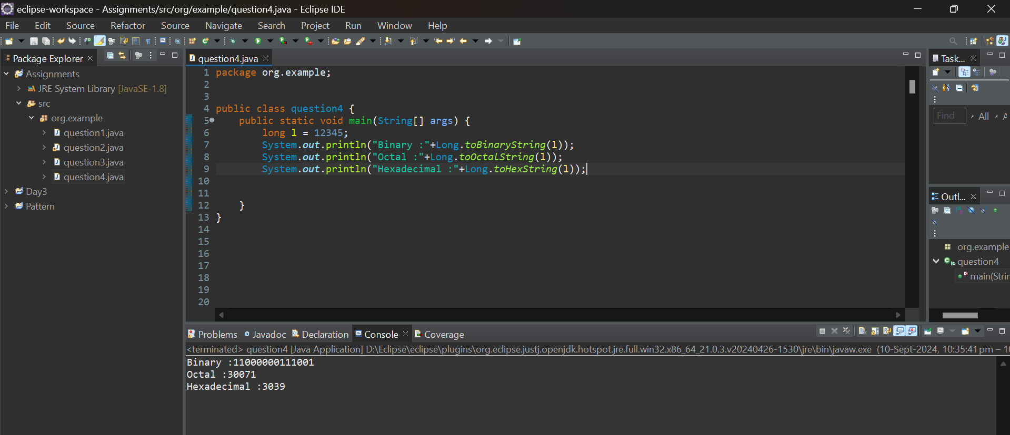

**l.** Experiment with converting a long value into other primitive types or vice versa and observe the result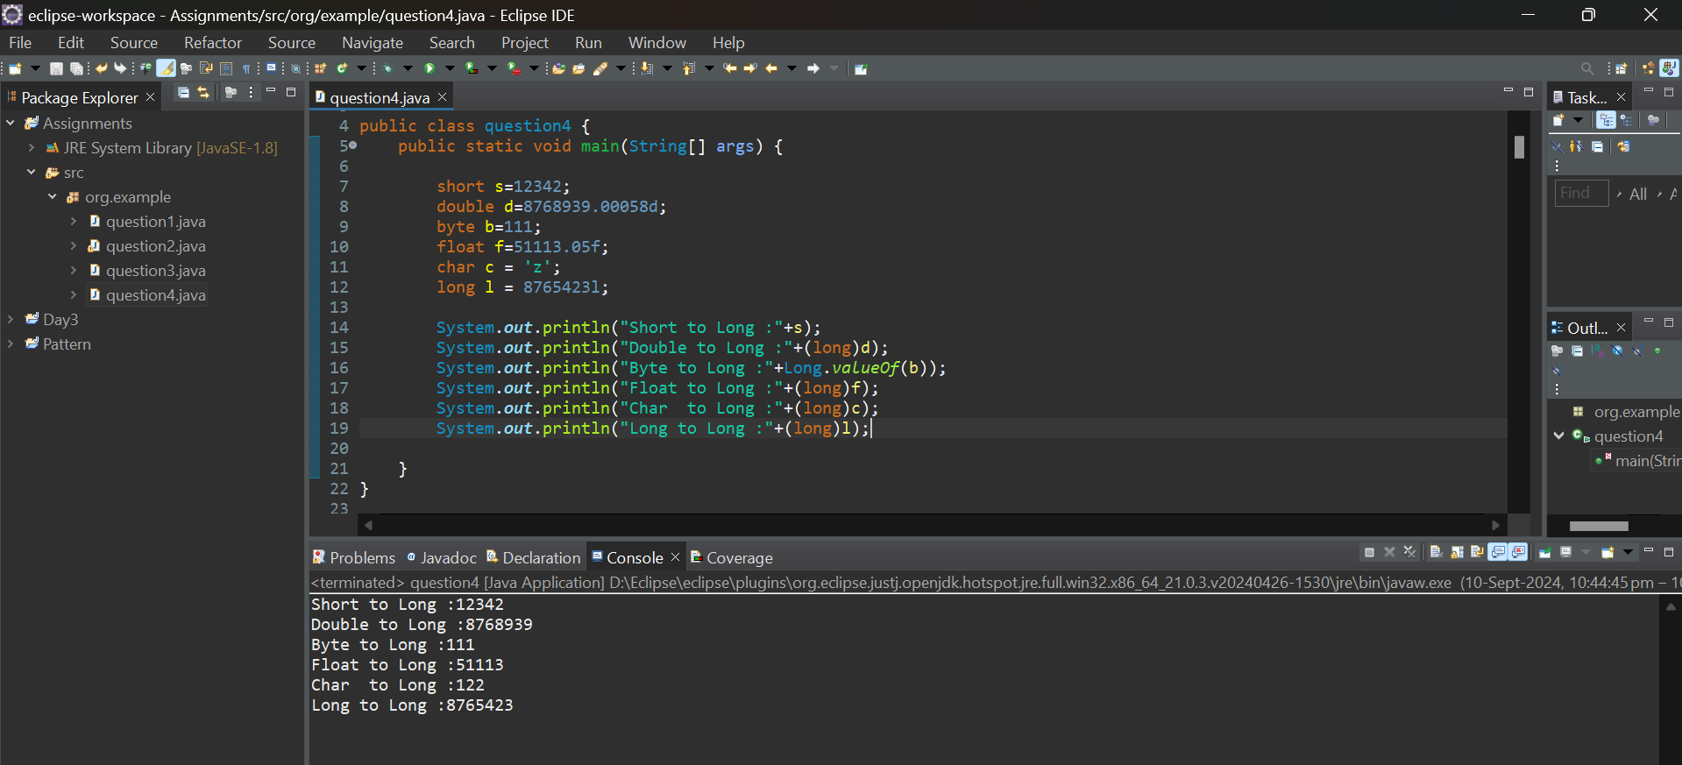

#### ****6. Working with**** java.lang.Float

**b.** Write a program to test how many bytes are used to represent a float value using the BYTES field. (Hint: Use Float.BYTES).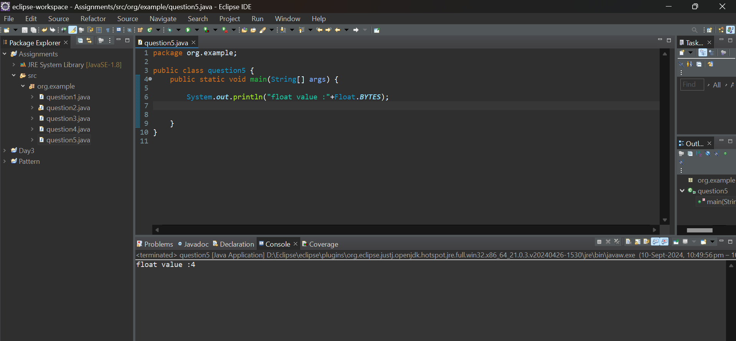

**c.** Write a program to find the minimum and maximum values of float using the MIN_VALUE and MAX_VALUE fields. (Hint: Use Float.MIN_VALUE and Float.MAX_VALUE).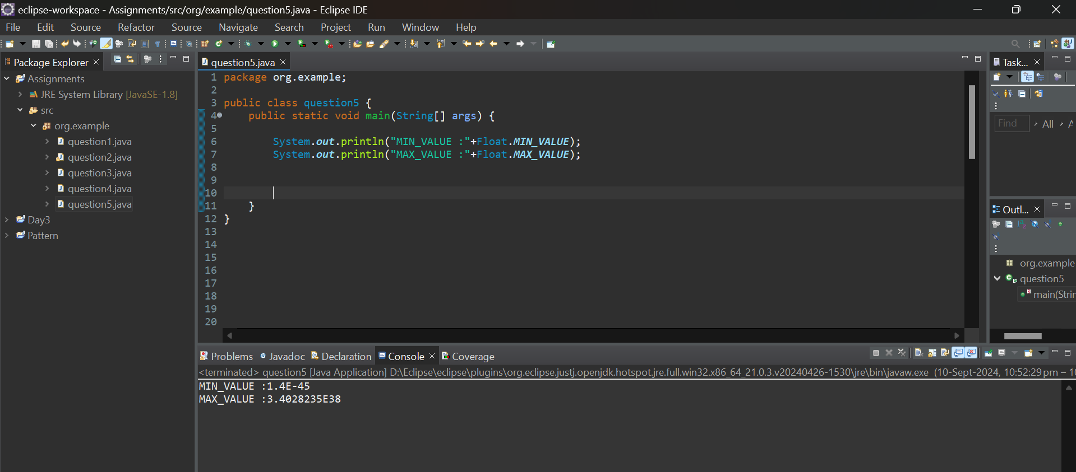

**d.** Declare a method-local variable number of type float with some value and convert it to a String using the toString method. (Hint: Use Float.toString(float)).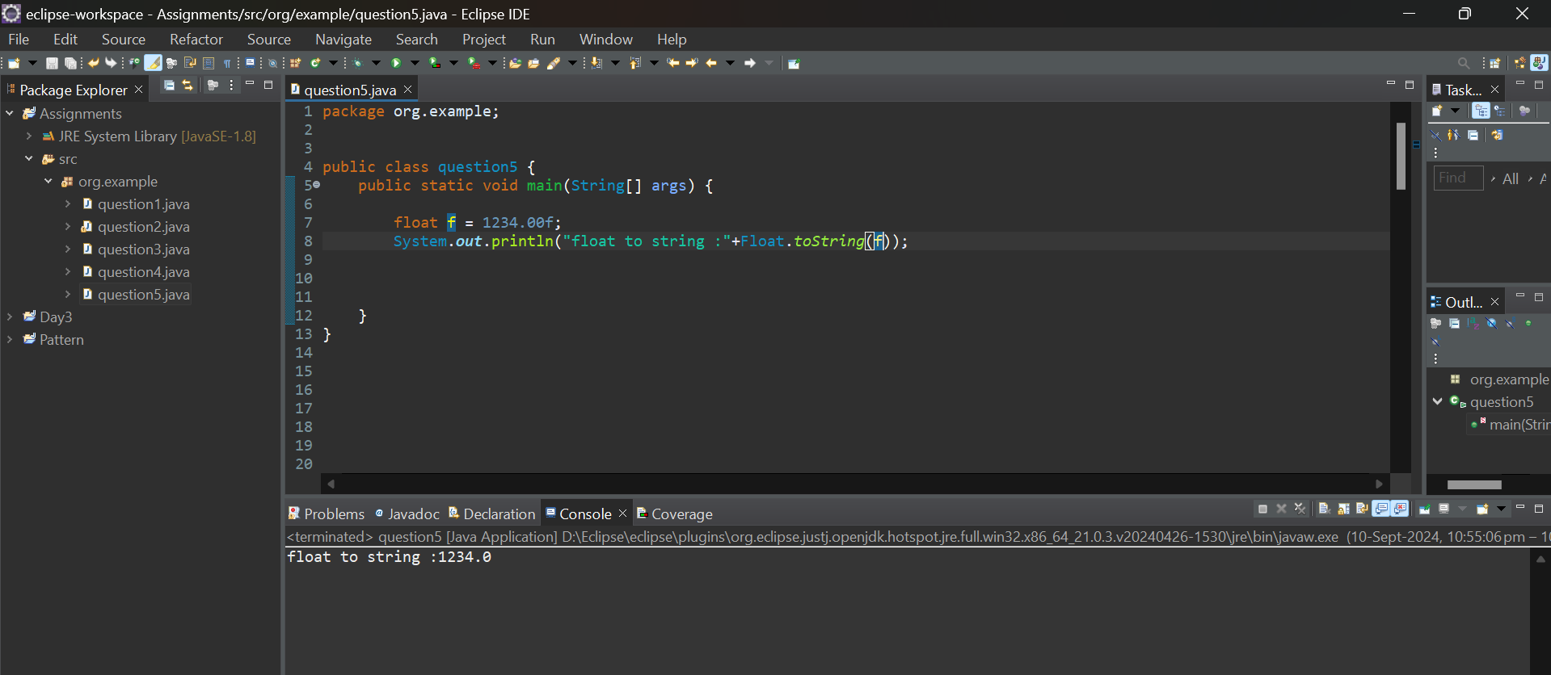

**e.** Declare a method-local variable strNumber of type String with some value and convert it to a float value using the parseFloat method. (Hint: Use Float.parseFloat(String)).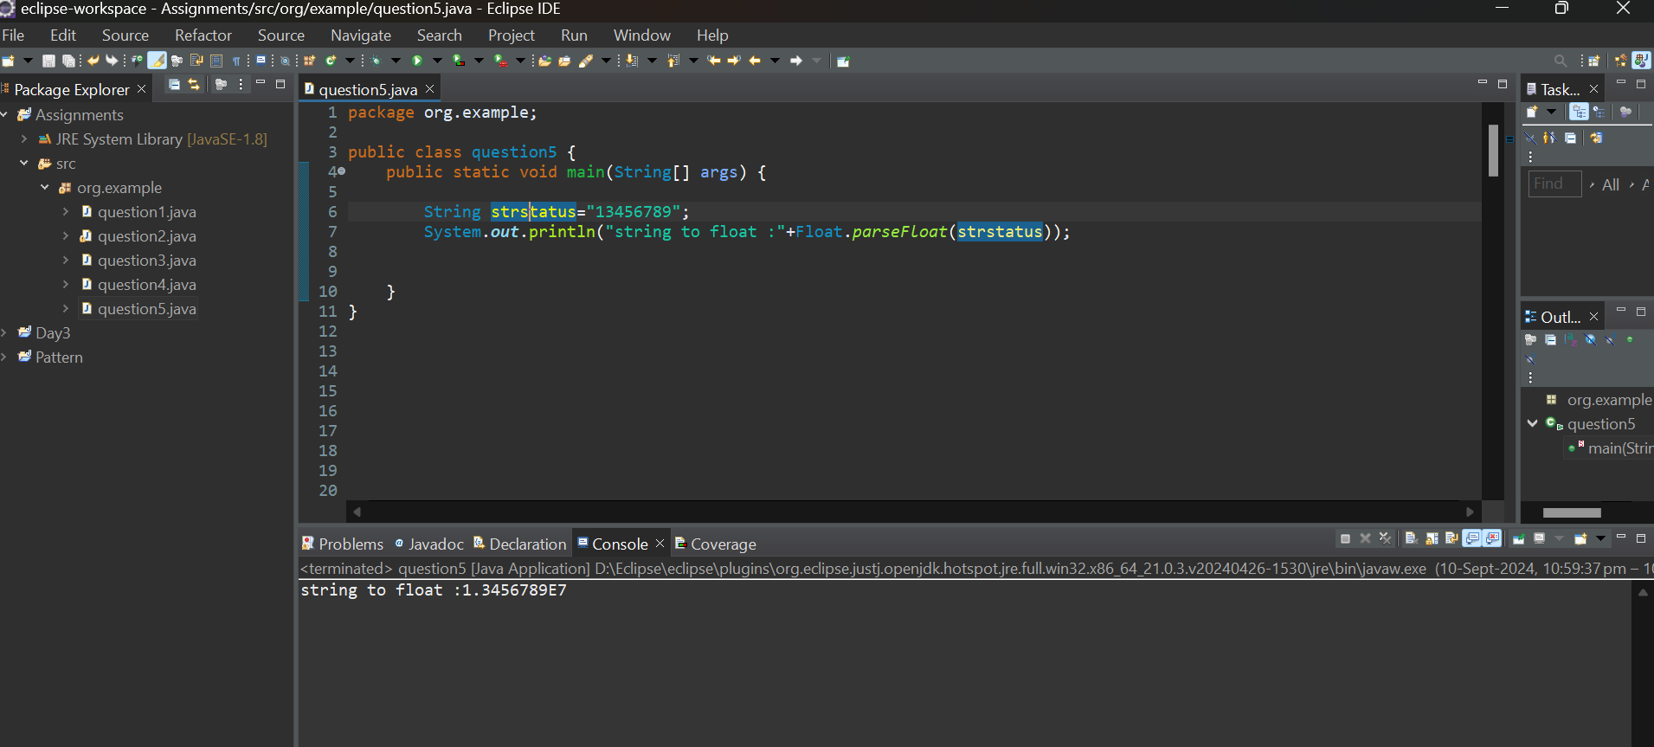

**f.** Declare a method-local variable strNumber of type String with the value "Ab12Cd3" and attempt to convert it to a float value. (Hint: parseFloat method will throw a NumberFormatException).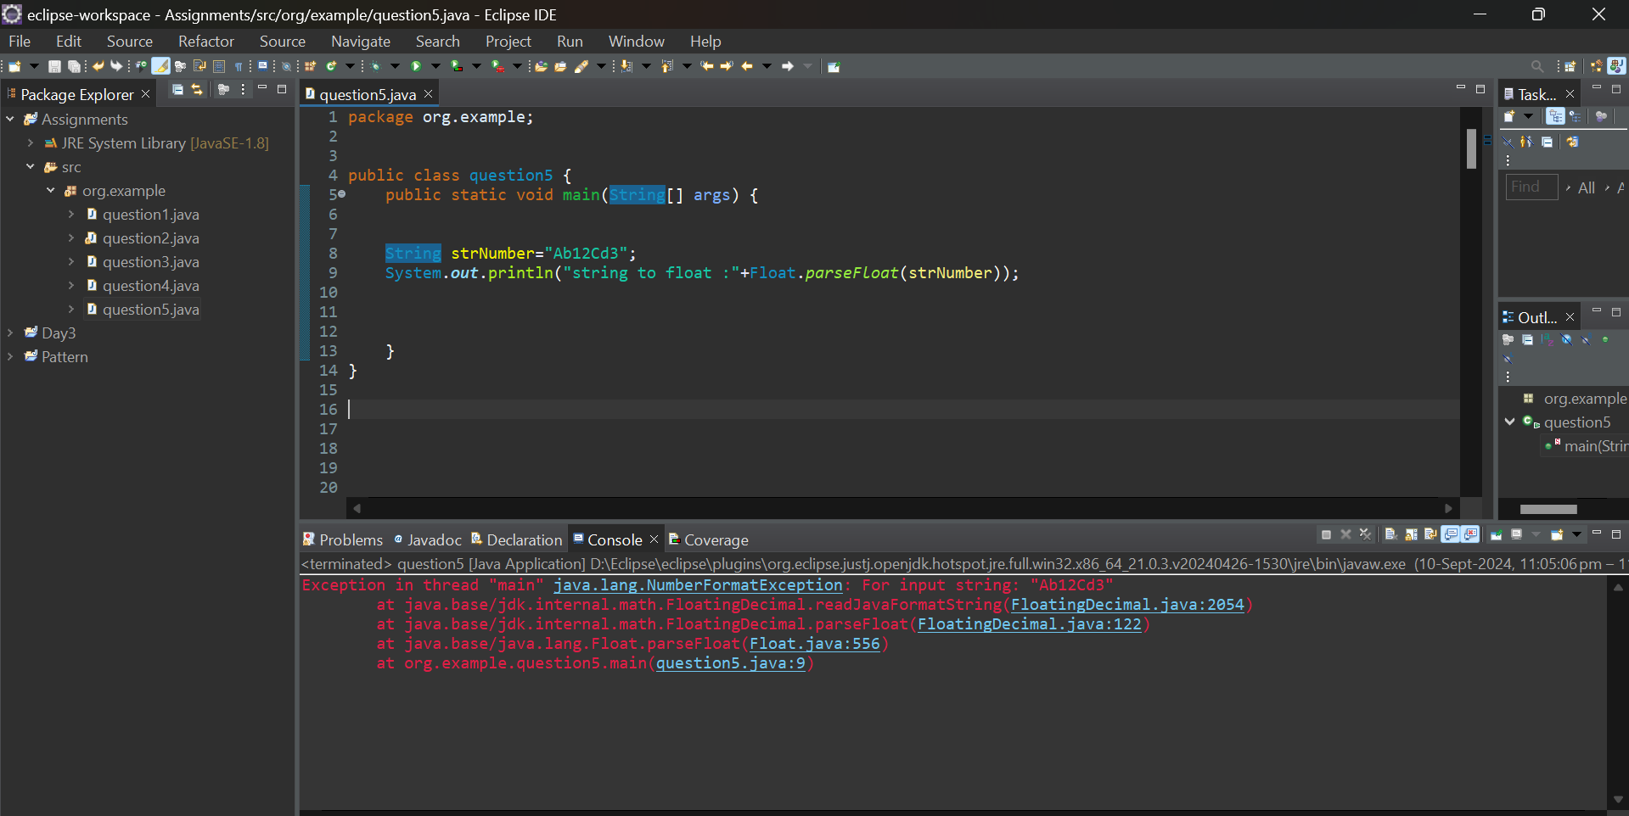

**g.** Declare a method-local variable number of type float with some value and convert it to the corresponding wrapper class using Float.valueOf(). (Hint: Use Float.valueOf(float)).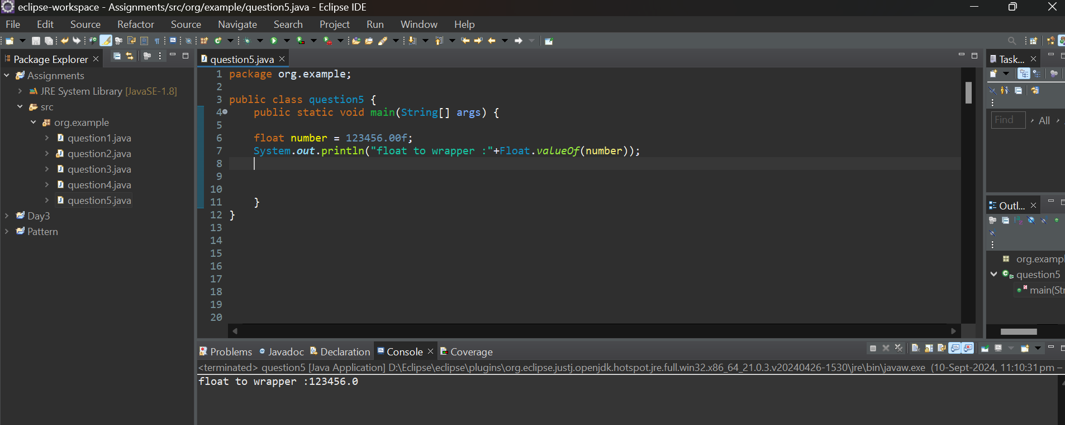

**h.** Declare a method-local variable strNumber of type String with some float value and convert it to the corresponding wrapper class using Float.valueOf(). (Hint: Use Float.valueOf(String)).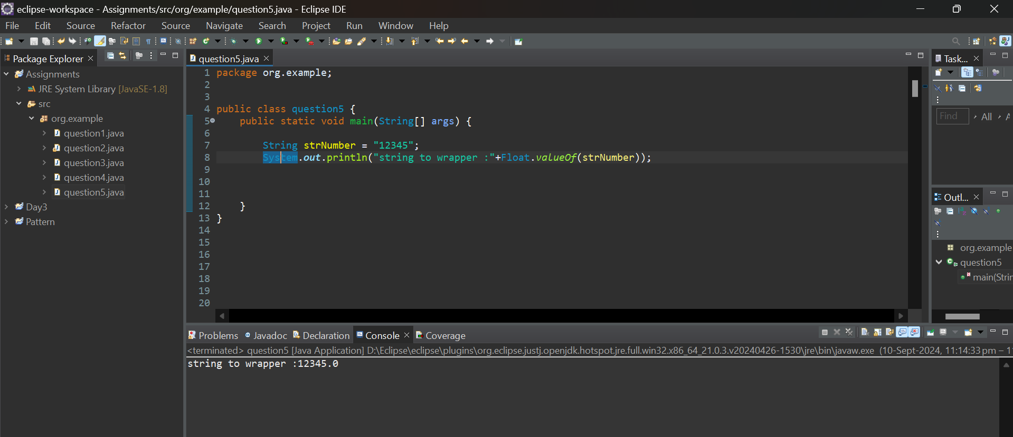

**i.** Declare two float variables with values 112.3 and 984.5, and add them using a method from the Float class. (Hint: Use Float.sum(float, float)).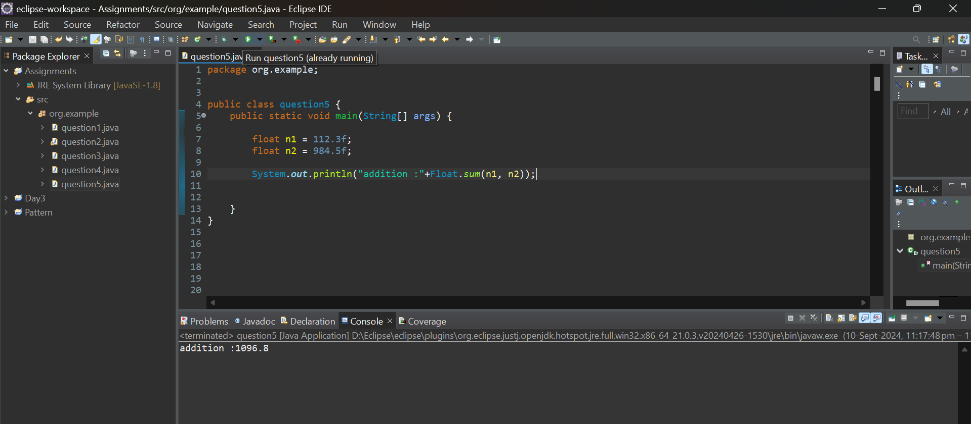

**j.** Declare two float variables with values 112.2 and 556.6, and find the minimum and maximum values using the Float class. (Hint: Use Float.min(float, float) and Float.max(float, float)).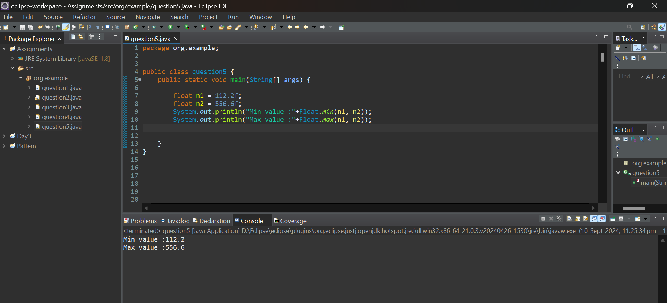

**k.** Declare a float variable with the value -25.0f. Find the square root of this value. (Hint: Use Math.sqrt() method).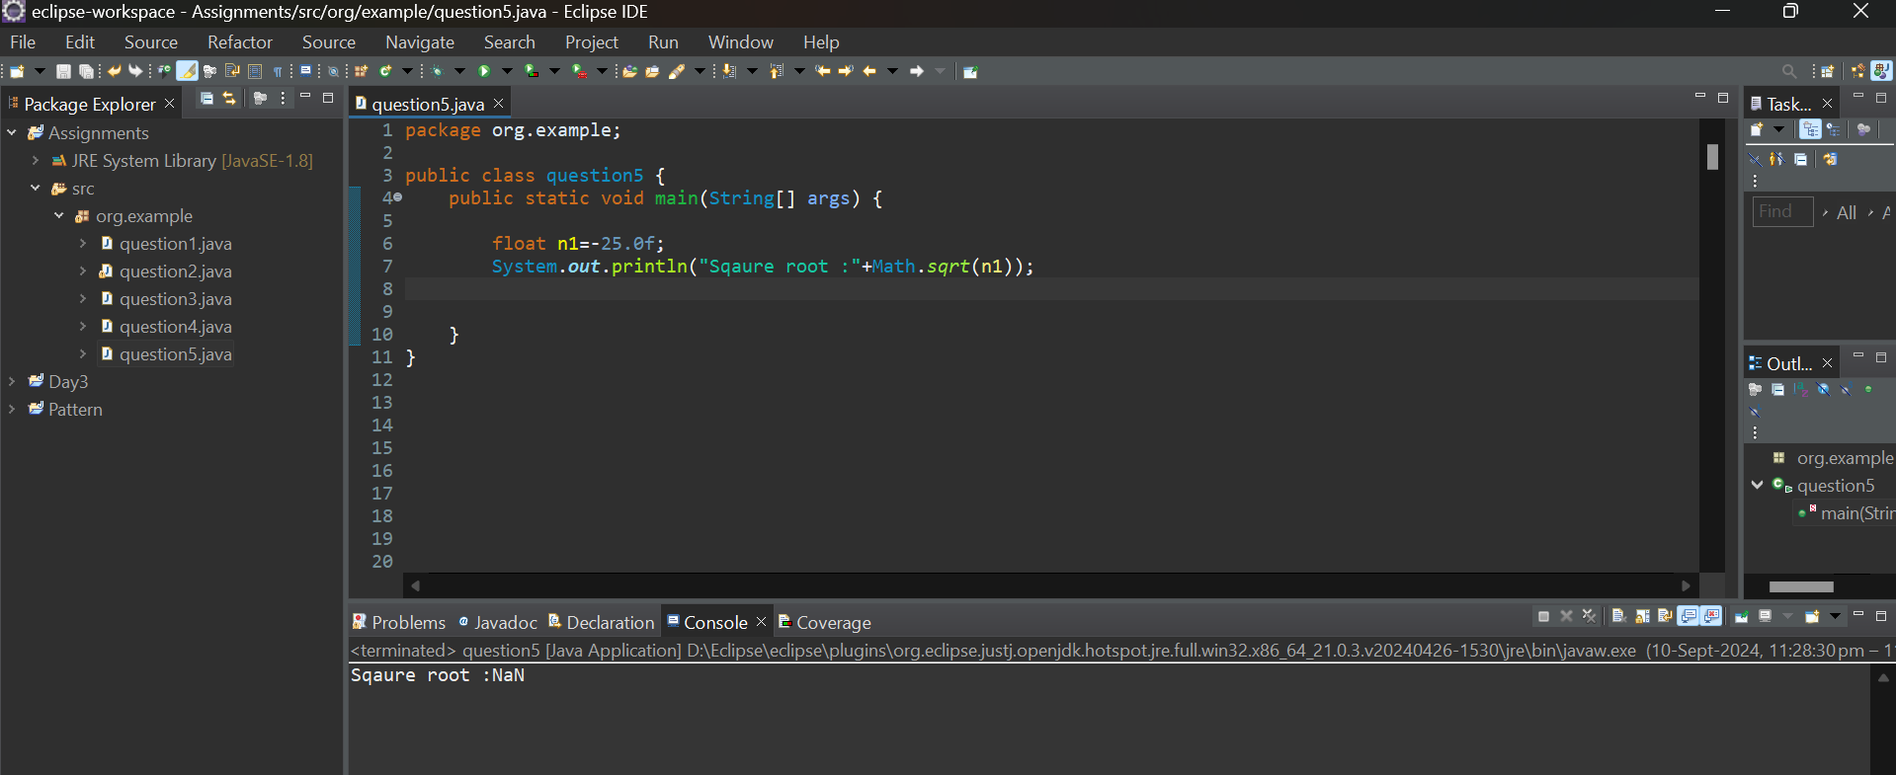

**l.** Declare two float variables with the same value, 0.0f, and divide them. (Hint: Observe the result and any special floating-point behavior).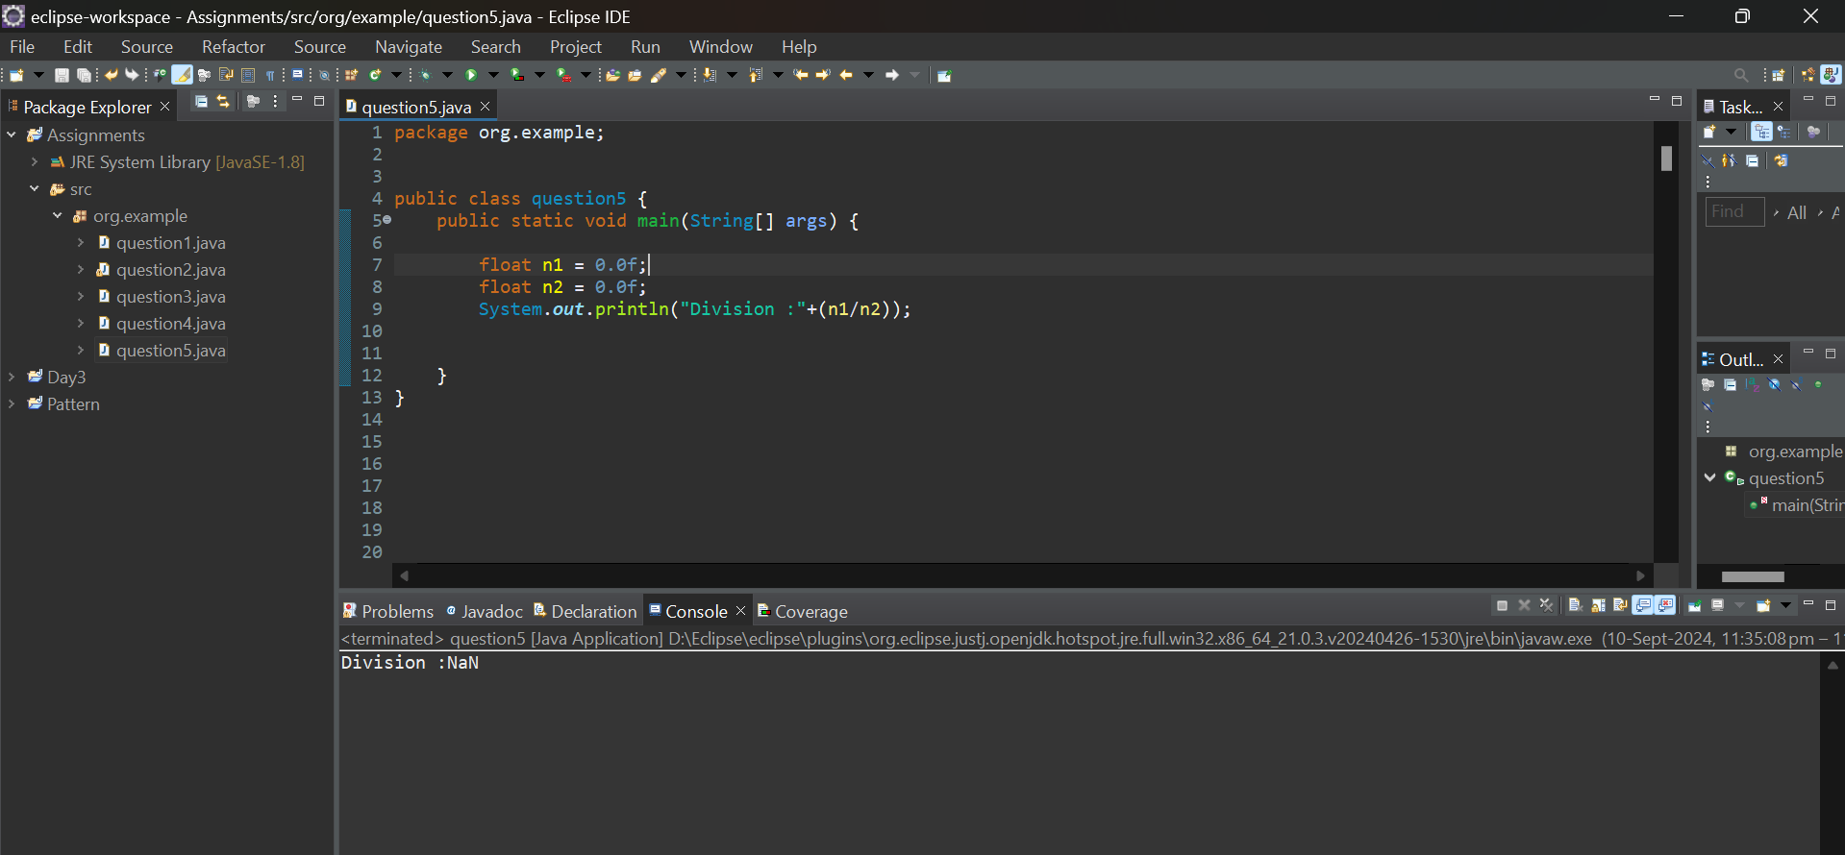

#### ****7. Working with**** java.lang.Double

**b.** Write a program to test how many bytes are used to represent a double value using the BYTES field. (Hint: Use Double.BYTES).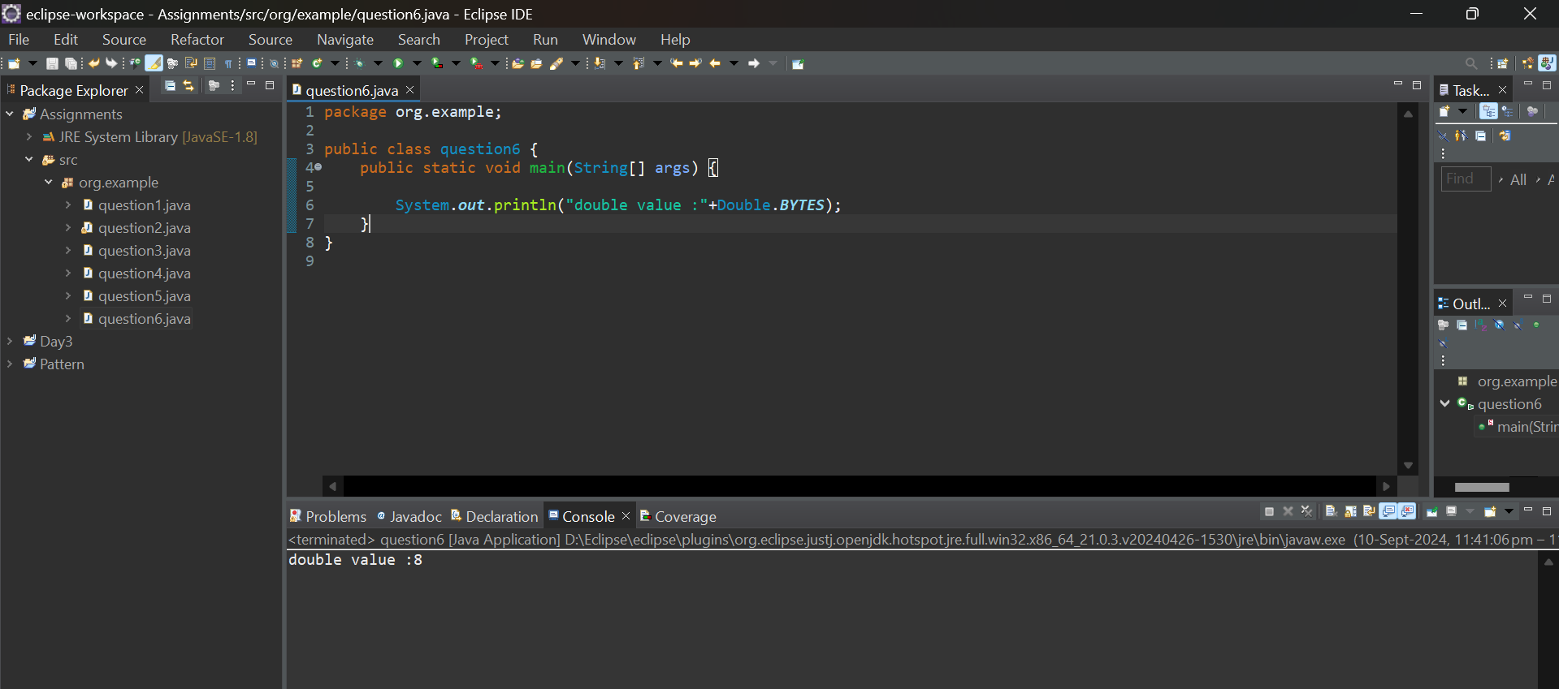

**c.** Write a program to find the minimum and maximum values of double using the MIN_VALUE and MAX_VALUE fields. (Hint: Use Double.MIN_VALUE and Double.MAX_VALUE).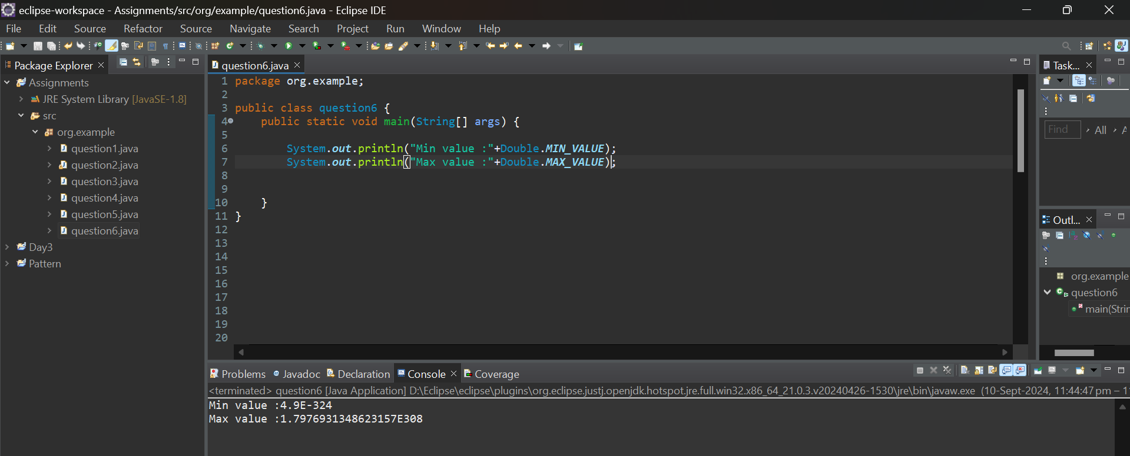

**d.** Declare a method-local variable number of type double with some value and convert it to a String using the toString method. (Hint: Use Double.toString(double)).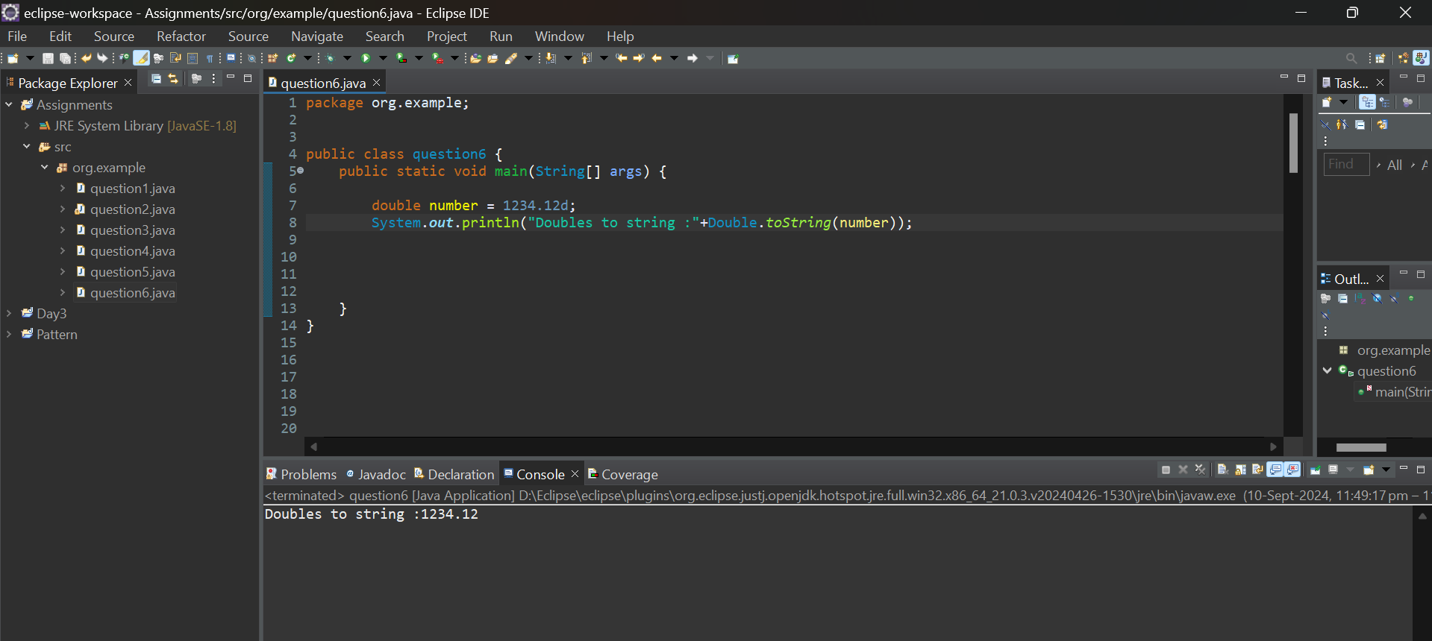

**e.** Declare a method-local variable strNumber of type String with some value and convert it to a double value using the parseDouble method. (Hint: Use Double.parseDouble(String)).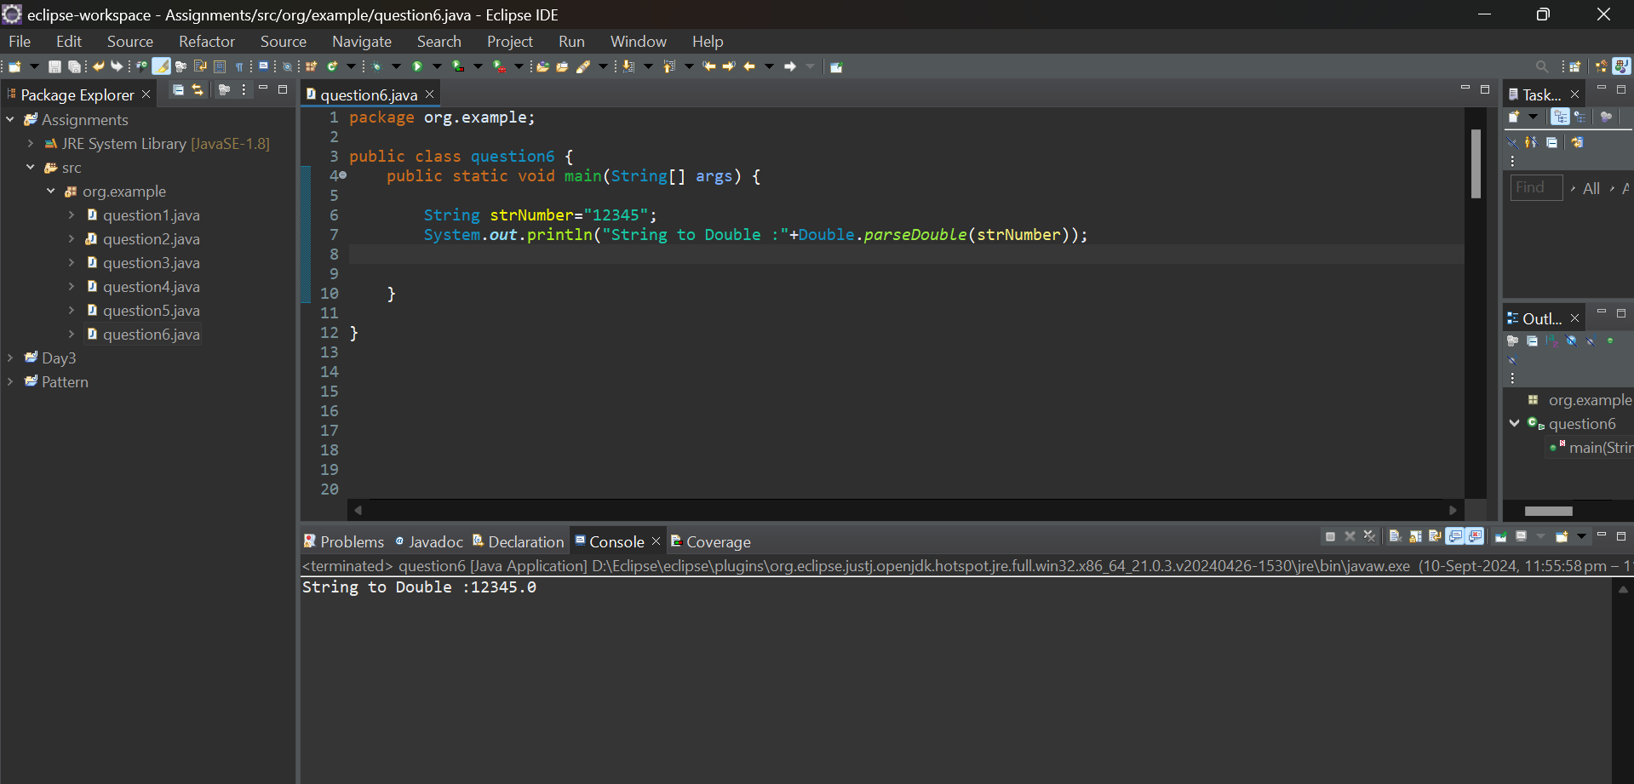

**f.** Declare a method-local variable strNumber of type String with the value "Ab12Cd3" and attempt to convert it to a double value. (Hint: parseDouble method will throw a NumberFormatException).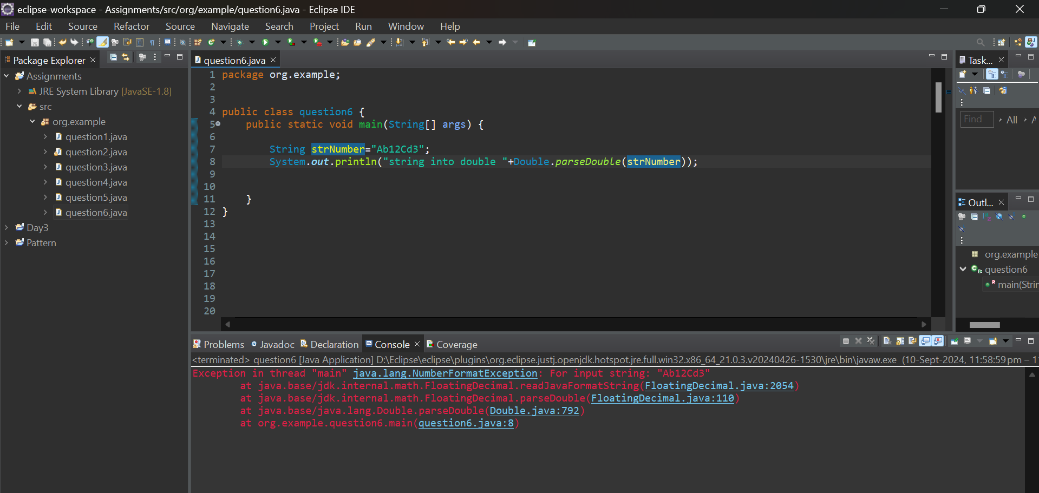

**g.** Declare a method-local variable number of type double with some value and convert it to the corresponding wrapper class using Double.valueOf(). (Hint: Use Double.valueOf(double)).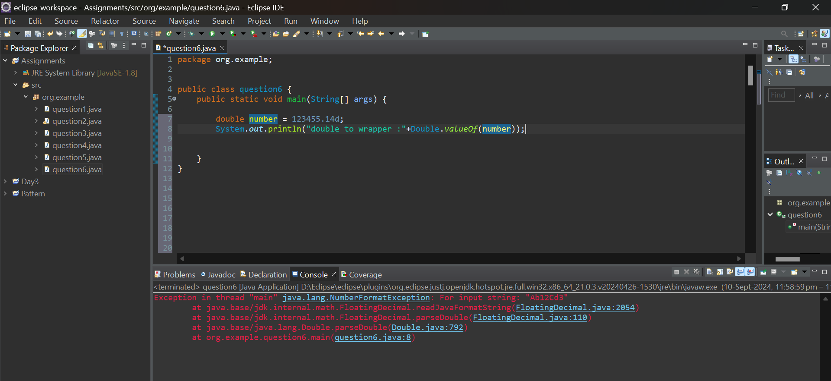

**h.** Declare a method-local variable strNumber of type String with some double value and convert it to the corresponding wrapper class using Double.valueOf(). (Hint: Use Double.valueOf(String)).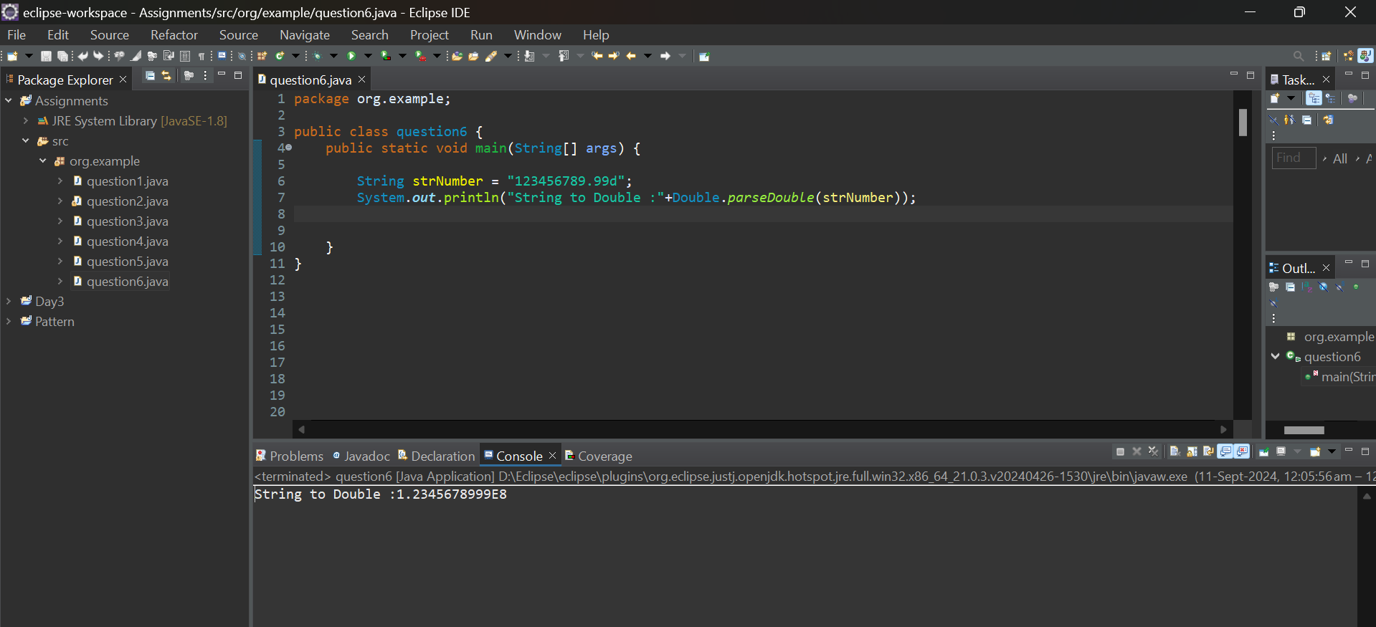

1. Declare two double variables with values 112.3 and 984.5, and add them using a method from the Double class. (Hint: Use Double.sum(double, double))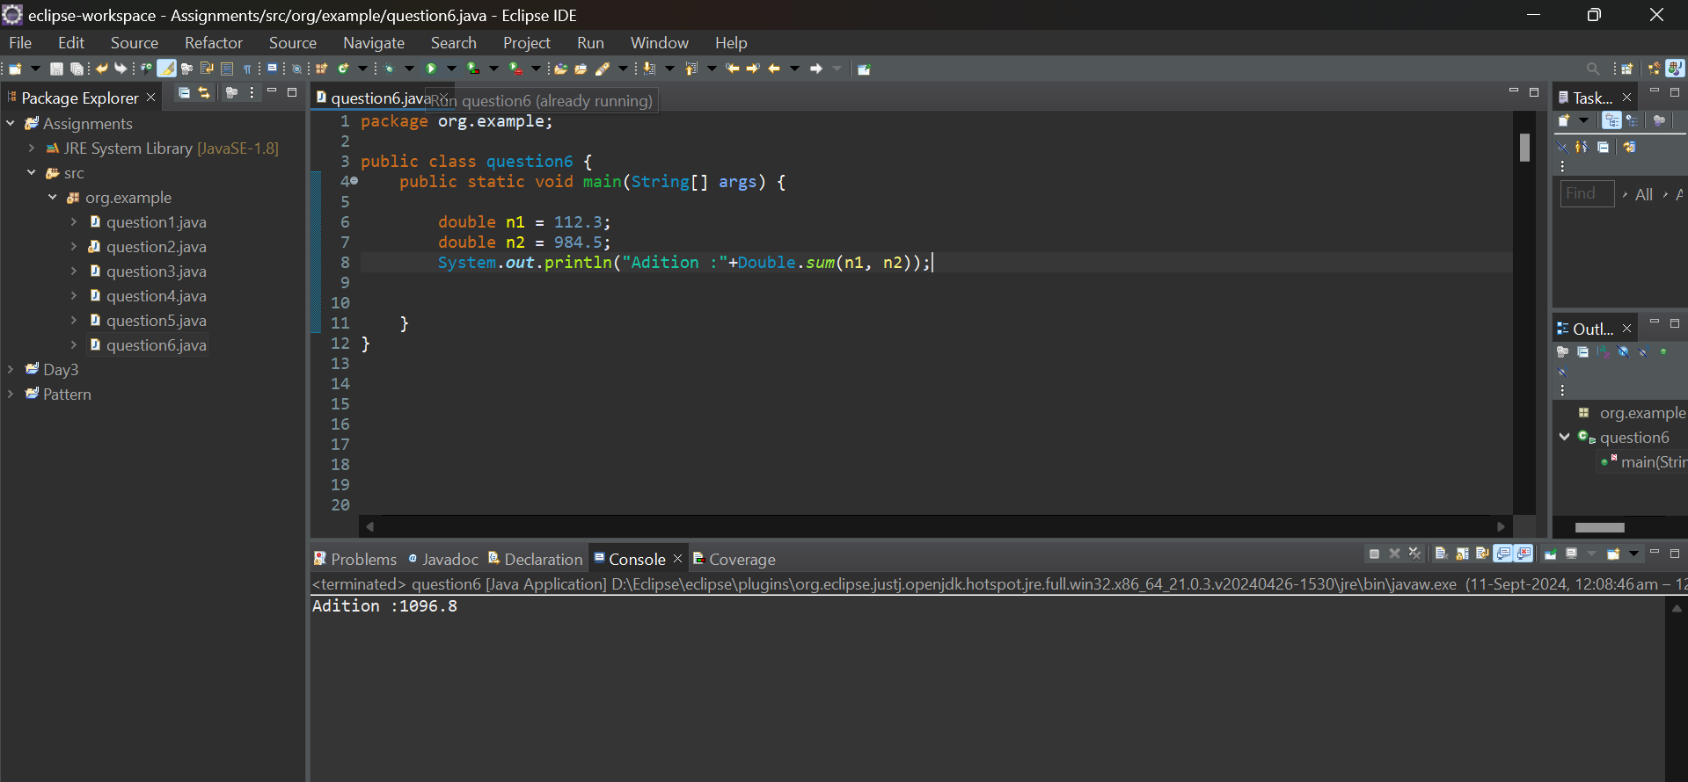

**j.** Declare two double variables with values 112.2 and 556.6, and find the minimum and maximum values using the Double class. (Hint: Use Double.min(double, double) and Double.max(double, double)).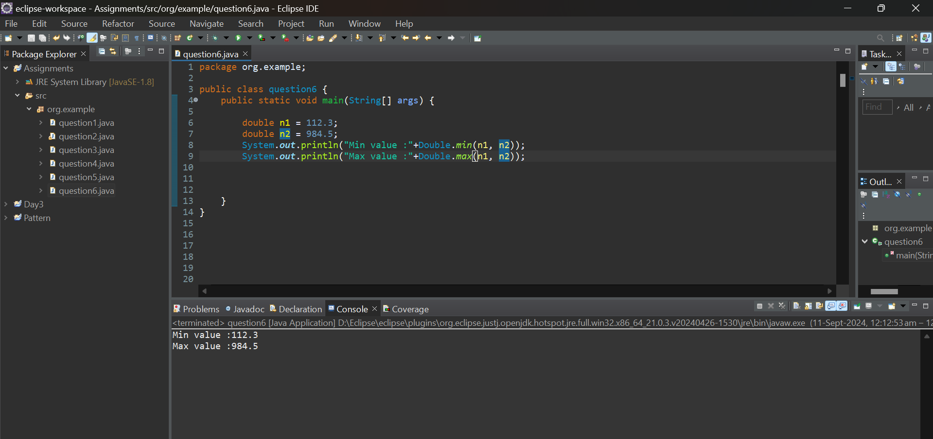

**k.** Declare a double variable with the value -25.0. Find the square root of this value. (Hint: Use Math.sqrt() method).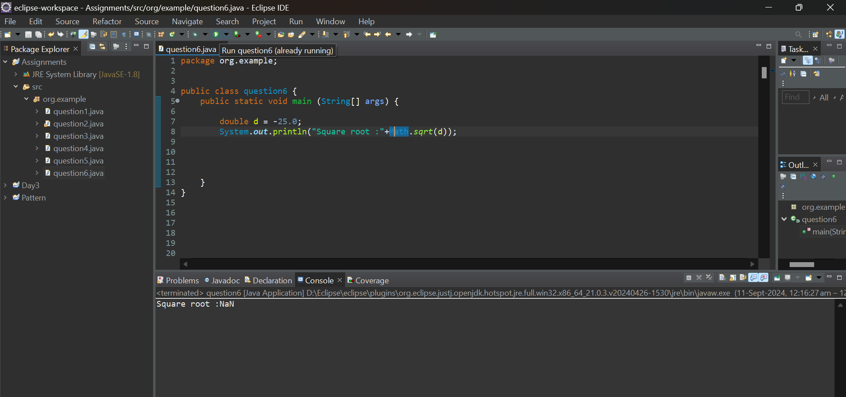

#### ****Default Values of Primitive Types****

Declare variables of each primitive type as fields of a class and check their default values. (Note: Default values depend on whether the variables are instance variables or static variables).

